CIRCULAR CLASSIFIER
A MINI PROJECT REPORT
Submitted by
THIRUNAVUKARASU S (2503917762221009)
ASWIN C (2503917762221001)
in partial fulfillment for the award of the degree
of
MASTER OF COMPUTER APPLICATIONS
in
DEPARTMENT OF COMPUTER APPLICATIONS
THIAGARAJAR COLLEGE OF ENGINEERING, MADURAI – 15
(A Government Aided Autonomous Institution Affiliated to Anna University)

ANNA UNIVERSITY: CHENNAI 600 025
NOV 2025
THIAGARAJAR COLLEGE OF ENGINEERING MADURAI-15
(A Government Aided Autonomous Institution Affiliated to Anna University)
BONAFIDE CERTIFICATE
Certified that this project report “CIRCULAR CLASSIFIER” is the bonafide work of “THIRUNAVUKARASU S (2503917762221009), ASWIN C (2503917762221001)” who carried out the Mini project work under my supervision during the Academic Year 2025-2026.
SIGNATURE
Dr.P.Chitra, M.E., Ph.D.,
FACULTY INCHARGE &
HEAD OF THE DEPARTMENT
COMPUTER APPLICATIONS
THIAGARAJAR COLLEGE OF ENGG.
MADURAI – 625 015
Submitted for the VIVA VOCE Examination held at Thiagarajar College of
Engineering on ………………
INTERNAL EXAMINER EXTERNAL EXAMINER
Declaration
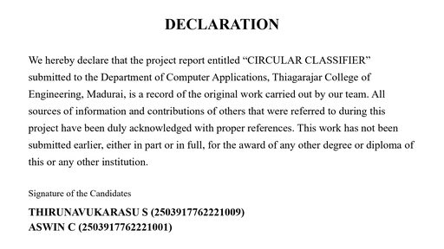
Acknowledgement
We wish to express our deep sense of gratitude to Dr. L.Ashok Kumar,
Principal of Thiagarajar College of Engineering for his support and
encouragement throughout this project work.
We wish to express our sincere thanks to Dr.P.Chitra, Head of the
Department of Computer Applications for her support and ardent guidance.
We owe our special thanks and gratitude to the faculty incharge Dr.P.Chitra
Professor, Department of Computer Applications for her guidance and
support throughout our project.
We are also indebted to all the teaching and non-teaching staff members of
our college for helping us directly or indirectly by all means throughout the
course of our study and project work.
We extremely thank our parents, family members and friends for their moral
support and encouragement for our project.
TABLE OF CONTENTS
CHAPTER NO: Title Page No:
ABSTRACT i
LIST OF FIGURES ii
LIST OF ABBREVIATIONS iii
1. INTRODUCTION 1
1.1 INTRODUCTION 1
1.2 ORGANISATION PROFILE 2
1.3 EXISTING SYSTEM 3
2. PROBLEM DESCRIPTION 4
2.1 PROBLEM STATEMENT 4
2.2 OBJECTIVES 4
3. SYSTEM REQUIREMENT SPECIFICATION 5
3.1 SCOPE 5
3.2 FUNCTIONAL REQUIREMENTS 5
3.2.1. Software Specification 6
3.2.2. Hardware Specification 7
4. PROPOSED SYSTEM 8
4.1 Methodology 8
4.2 Advantages of the proposed System 9
5. SYSTEM DESIGN 10
5.1 SYSTEM ARCHITECTURE DIAGRAM 10
5.2 DATA FLOW DIAGRAM 11
5.2.1 Level 0 DFD 11
5.2.2 Level 1 DFD 11
5.2.3 Level 2 DFD 12
5.3 LOGICAL DESIGN USING UML 13
5.3.1 Usecase Diagram 13
5.4 PHYSICAL DESIGN USING UML 13
5.4.1 Component Diagram 13
5.4.2 Deployment Diagram 14
6. MODULE DESCRIPTION 15
6.1 Authentication Module 15
6.2 Dashboard Module 15
6.3 Circulars Module 15
6.4 Email & OCR Module 16
6.5 Classification Module 16
6.6 Expiry Alerts Module 16
6.7 Search Module 16
6.8 Admin Module 16
6.9 Attachments Module 16
7. RESULTS AND IMPLEMENTATION 17
8. CONCLUSIONS 25
9. BIBLIOGRAPHY 27
10. APPENDICES 28
10.1 APPENDIX –A PROJECT SCREEN SHOTS 28
Abstract
In today's fast-paced academic environment, higher education
institutions issue a large number of circulars, notices and announcements
every day covering examinations, placements, academic schedules, holidays
and administrative instructions. These circulars are usually distributed
through email groups, notice boards and messaging applications, making
important information difficult to track, search and prioritise. As a result,
students and staff often miss critical deadlines. The Circular Classifier has
therefore been developed as a centralized institutional circular management
system that automatically collects incoming circulars, extracts their text,
classifies them into meaningful categories, detects expiry dates and organises
everything by priority for easy retrieval.
The system has been designed and implemented as a full-stack web
application using React with Vite (TypeScript and Tailwind CSS) for the
front-end and Node.js with Express for the back-end. Circulars are received
from a mail server through IMAP, processed by background workers built on
Redis and Bull queues, and analysed using Tesseract OCR together with PDF
and DOCX text extraction. A keyword classifier automatically assigns each
circular to a category such as Examinations, Academic, Placements,
Holidays, Events or Administration, while an expiry-date detector highlights
the circulars that are ending soon. All records, categories, users and logs are
stored in MongoDB, and the application provides a dashboard, instant
keyword search with filters and an administrative console.
Deploying this system offers several advantages to the institution. It
removes the dependence on scattered email threads and notice boards,
ensures that every circular is captured and archived in one place, and greatly
reduces the effort required to find an old notice. Priority-based sorting and
expiry alerts help students and staff act on time-critical announcements,
while the classification and search modules make large volumes of
information easy to navigate. The modular architecture allows new categories
and notification channels to be added without disturbing existing modules. In
the long term, the system can be extended with mobile notifications,
multi-institution support and analytics
dashboards.
i
LIST OF FIGURES
Figure Index. | Title of the Figure | Page No.
5.1 | System Architecture Diagram | 10
5.2.1 | Data Flow Diagram – Level 0 | 11
5.2.2 | Data Flow Diagram – Level 1 | 11
5.2.3 | Data Flow Diagram – Level 2 | 12
5.3.1 | Usecase Diagram | 13
5.4.1 | Component Diagram | 13
5.4.2 | Deployment Diagram | 14
ii
LIST OF ABBREVIATIONS
S.No | Abbreviation | Full Form
1 | HTML | HyperText Markup Language
2 | CSS | Cascading Style Sheets
3 | JS | JavaScript
4 | PaaS | Platform as a Service
5 | UI | User Interface
6 | UX | User Experience
7 | API | Application Programming Interface
8 | DFD | Data Flow Diagram
9 | UML | Unified Modeling Language
10 | IDE | Integrated Development Environment
11 | ISO | International Organization for  Standardization
12 | VS Code | Visual Studio Code
13 | Git | Global Information Tracker
14 | B2B | Business to Business
15 | SEO | Search Engine Optimization
iii
1. INTRODUCTION
1.1 INTRODUCTION
React.js
The front-end of the Circular Classifier is built with React, a JavaScript library
developed by Meta for creating dynamic and reusable user-interface components. Each
part of the application, such as the dashboard, the circular table, the search panel and the
admin console, is implemented as an independent, reusable component. React's virtual
DOM updates only the parts of a page that change, keeping large circular listings fast and
responsive, and its declarative style makes the code predictable and easy to debug while
improving maintainability and scalability.
JavaScript (ES6)
JavaScript, particularly the ES6 (ECMAScript 2015) version, is used throughout
the client to add interactivity and logical control. Features such as arrow functions,
template literals, promises and modular imports keep the code concise and maintainable.
JavaScript handles user events, asynchronous API calls, live search and the dynamic
rendering of circular data, ensuring that the interface responds instantly to user
actions.
GitHub for Collaboration
GitHub is used for version control and collaborative development. The team stored
the source code in GitHub repositories, created branches for individual features and
tracked every change through commits and pull requests. This produced a clear version
history, minimised conflicts between the two developers and allowed features to be
integrated smoothly throughout the project.
Cloud Deployment (PaaS)
The application is deployed on a cloud Platform-as-a-Service environment so that
it remains accessible to all users without dedicated institutional servers. Continuous
deployment from the GitHub repository keeps the live build up to date, and a global
content-delivery network reduces latency for users. The same deployment pipeline serves
the Node.js API and the static client build, providing a simple and reliable
hosting
setup.
1
1.2 ORGANISATION PROFILE
Thiagarajar College of Engineering (TCE), Madurai, established in 1957, is a
government-aided autonomous institution affiliated to Anna University, Chennai. It is one
of the most reputed engineering colleges in Tamil Nadu, offering undergraduate,
postgraduate and doctoral programmes in engineering, technology, architecture and
computer applications, and is accredited by the National Assessment and Accreditation
Council
(NAAC).
The Department of Computer Applications offers the Master of Computer
Applications (MCA) programme and focuses on software engineering, web technologies,
databases and emerging areas such as data science and cloud computing. The department
provides well-equipped laboratories, high-speed internet and a project-oriented curriculum
that encourages students to build complete, deployable software systems under the
guidance of experienced
faculty.
The vision of the department is to produce competent and socially responsible
computer professionals who can design and deliver innovative software solutions. Its
mission is to impart quality technical education, promote research and teamwork, and
nurture ethical values. These objectives guided the development of the Circular Classifier
as a practical, socially useful project that addresses a genuine communication problem
faced by institutions.
The strengths of the department lie in its experienced faculty, well-structured
curriculum and active project culture. Students are encouraged to work in teams, adopt
modern development tools and follow standard software processes, which closely matches
the way the Circular Classifier project was planned, executed and documented by the
team.
In line with the department's emphasis on full-stack and cloud-ready skills, the
project uses a modern technology stack that includes React with Vite and TypeScript,
Node.js with Express, MongoDB, Redis and Bull background workers, Tesseract OCR
and a keyword-based classifier. The institution actively promotes such end-to-end
projects, as they prepare students for real-world software development and provide useful
tools for the campus community. With its strong academic foundation, technical
infrastructure and supportive mentoring, the department provided an ideal environment in
which the Circular Classifier was designed, implemented and
evaluated.
2
1.3 EXISTING SYSTEM
Module  description | Existing manual method  used | Drawbacks of the  existing method | Features proposed to  overcome
Distribution | Emails, notice boards and  messaging groups | Circulars are scattered  across mails and easily  missed | Automatic ingestion from  email and uploads into one  searchable and central  repository
Classification | Manual tagging or no  labelling | Notices are hard to find  by topic | Keyword-based classifier  assigns categories  automatically
Search | Scrolling through long mail  threads | Old circulars are difficult  to retrieve | Instant keyword search with  category, priority, tag and  date filters
Priority &  Expiry  management | No concept of priority or  deadlines | Urgent notices and  deadlines are missed,  urgent mails remain  unnoticed, and priority is  never reflected anywhere | Automatic priority levels  and expiry-date alerts with  reminders for pending  actions
Dashboard | No single view of active  circulars | Users cannot see what  needs attention or which  circulars are due soon | Dashboard sorted by date  and priority with an  'Ending Today' view
Attachments | Files attached to separate  emails and scattered across  mail threads | Attachments lose context  and are hard to locate | Attachments stored and  linked to their circulars in  one place
Users | Open mailing lists and chat  groups | No control over who  publishes notices or edits  them after publishing,  and no audit trail | Role-based accounts for  students, staff and  administrators with per-role  publish, edit and delete  rights
3
2. PROBLEM DESCRIPTION
2.1 PROBLEM STATEMENT
Educational institutions publish a constant stream of circulars covering
examinations, results, placements, fee deadlines, holidays and administrative instructions.
In most institutions these circulars are shared through email groups, printed notice boards
or messaging applications, and there is no single place where they are stored or searched.
Important announcements get buried under newer messages, duplicate copies circulate in
different groups, and students frequently miss deadlines. Tracking which circulars are still
valid, which are urgent and which relate to a particular department is extremely
difficult.
The absence of a centralized platform also creates extra work for the
administrative staff, who must resend the same information repeatedly and answer the
same queries. Hence there is a clear need for a professional, searchable and priority-aware
circular management system that can serve as a single source of truth for every
institutional announcement.
2.2 OBJECTIVES
● To design and develop a centralized web application that collects institutional
circulars from email and file sources automatically.
● To extract text from PDF, DOCX and image attachments using Tesseract OCR and
document-parsing libraries.
● To classify circulars into categories with a keyword-based classifier and to assign
priority levels automatically.
● To detect expiry dates and highlight circulars that are ending soon through
dashboards and alerts.
● To provide instant keyword search with category, priority and date filters.
● To build an administrative console for managing categories, keywords and user
accounts, and to use GitHub for collaboration and version control.
4
3. SYSTEM REQUIREMENT SPECIFICATION
3.1 SCOPE
This project focuses on developing a centralized circular management system for
educational institutions. It collects circulars from a mail server and from uploaded
documents, processes them automatically, classifies them by category and presents them
through a searchable, priority-aware web interface.
The scope covers the complete workflow of circular handling: ingestion, text
extraction, classification, expiry detection, storage, search and administration. It is
designed for institutional use but can be adapted to any organization that distributes large
volumes of notices.
The system is built as a full-stack web application, with a React (Vite, TypeScript
and Tailwind CSS) client, a Node.js and Express REST API, MongoDB for storage, and
Redis with Bull for background jobs. Tesseract OCR, PDF and DOCX parsers are used
for text extraction. It is version-controlled with GitHub and deployed as a Node.js service
for reliable, always-available access.
3.2 FUNCTIONAL REQUIREMENTS
● The system should automatically fetch incoming circulars from the configured mail
server and also support manual document upload.
● It should extract text from email bodies and from PDF, DOCX and image
attachments, including scanned documents through OCR.
● It should classify each circular into a category using configurable keywords and
assign an appropriate priority.
● It should detect expiry dates and clearly indicate circulars that are expiring today or
soon.
● It should provide instant keyword search with filters for category, priority, tag,
sender and date range.
● It should present circulars on a dashboard sorted by date and priority, with a
detailed circular view.
● It should provide an admin console to manage categories, keywords and user
accounts, and must remain responsive across devices.
5
3.2.1 SOFTWARE SPECIFICATION
Frontend Framework – React.js
The client of the Circular Classifier is built using React, a JavaScript library for building
interactive, component-based user interfaces. Each major part of the application, such as
the dashboard, the circular table, the search panel and the admin console, is implemented
as a reusable component. This modular approach keeps the interface consistent, simplifies
maintenance and allows new screens to be added easily, while React's virtual DOM
keeps large circular listings fast and responsive.
Styling – Tailwind CSS
The interface is styled using Tailwind CSS, a utility-first CSS framework that provides
precise control over layout, typography, spacing and colour. Tailwind keeps the look and
feel consistent across every screen and device, and its responsive utilities make the
dashboard, tables and forms adapt cleanly to desktops, tablets and mobile phones.
Backend Framework – Node.js and Express
The back-end is built with Node.js and the Express framework. It exposes a REST API for
authentication, circulars, categories, search and user management. Redis and Bull queues
process heavy jobs such as extraction, classification and expiry detection asynchronously,
keeping the interface responsive.
Development Environment – Visual Studio Code (VS Code)
The project is developed in Visual Studio Code, a lightweight and feature-rich IDE that
supports debugging, extensions, integrated terminals and version control. VS Code
provides a flexible environment for writing React components and Node.js modules,
managing project files and testing both the client and the server efficiently.
Version Control – Git & GitHub
Git is used to track code changes, while GitHub enables collaborative development by
allowing both team members to work on different features simultaneously. It ensures a
structured workflow with version history, branch management and pull requests, making
teamwork efficient and reducing code conflicts.
Database – MongoDB
All application data, including circulars, users, categories and processing logs, is stored in
MongoDB, a document-oriented NoSQL database. MongoDB's flexible schema suits
circular data, which varies in structure and attachments, and the Mongoose ODM provides
clear models, validation and efficient queries for search and filtering.
6
3.2.2 HARDWARE SPECIFICATION
Development Environment
For development purposes, a system with an Intel i3 processor or higher, 4 GB RAM (8
GB recommended) and at least 20 GB of free storage is sufficient. This configuration
supports running Visual Studio Code, the Node.js server, MongoDB, Redis and a browser
simultaneously. A display with 1366 × 768 resolution or higher allows efficient testing of
the dashboard and responsive layouts.
Deployment Environment
The application is deployed on a cloud Node.js hosting environment with a managed
MongoDB database and a Redis instance for background queues. The platform
automatically manages server resources and scaling, ensuring that circulars are processed
reliably and the service stays accessible with low latency.
End-User Devices
The application is optimized for a wide range of devices. Users can access it seamlessly
from desktops, laptops, tablets and mobile phones, and the responsive design adapts to
various screen sizes and resolutions. Administrative users who upload or manage circulars
use the same interface, and only an internet connection and a modern browser are
required.
7
4. PROPOSED SYSTEM
4.1 Methodology
The proposed system is a full-stack, service-oriented web application for
managing institutional circulars, with a strong emphasis on automation, modular design
and usability. The methodology combines a layered client-server architecture with an
Agile development process, enabling iterative progress, continuous feedback and flexible
enhancements. The approach is described below by
feature:
1. Layered Client-Server Architecture
The system is divided into a React client, an Express REST API, background processors
and a MongoDB data layer. Each layer has a clear responsibility and communicates
through well-defined interfaces, so the client, server and workers can be developed, tested
and scaled independently while remaining easy to maintain.
2. Responsive Design
The interface is designed to work seamlessly across desktops, laptops, tablets and mobile
devices. Tailwind's responsive utilities adapt the dashboard, tables and forms to different
screen sizes, ensuring a consistent and intuitive experience for both staff and students on
any device.
3. Asynchronous Processing with Queues
Background jobs are processed asynchronously using Redis and Bull queues. When a
circular arrives from the mail server or is uploaded, a job is enqueued for text extraction,
OCR, classification and expiry detection. This keeps the API responsive, allows
long-running tasks to complete reliably and makes the processing pipeline easy to extend
with new steps.
4. Agile Development Methodology
The project follows Agile methodology, incorporating iterative sprints to achieve steady
progress. Sprint planning defined tasks for ingestion, extraction, classification, search and
the admin console. Each sprint concluded with internal reviews and testing, allowing early
detection of errors, continuous improvement and flexibility for design
changes.
5. Prototyping and Design Validation
Wireframes and mock-ups were created during the early stages of development to
visualise the dashboard, circular table, search and filter panels and admin screens. These
prototypes were validated against real circular data and user needs, ensuring that the final
interface was clear, consistent and aligned with the project goals.
8
6. Version Control and Collaboration
Git and GitHub were used for version control and collaborative development. This
ensured organised code management, easy rollback to previous versions when needed,
and efficient teamwork between the two developers who worked on different modules.
7. Deployment and Accessibility
The application is deployed on a cloud platform that serves the static client build and runs
the Node.js API with managed MongoDB and Redis services. This ensures the system is
highly available, processes circulars reliably in the background and can be accessed by
users across different regions.
4.2 Advantages of the Proposed System
The proposed system provides several distinct advantages, both from a technical and an
institutional perspective:
1. Modular and Maintainable Code
The layered architecture ensures that each module is independent and reusable. This
improves maintainability, reduces development time for future enhancements, and
simplifies debugging and testing.
2. Enhanced User Experience
A responsive, searchable interface with priority sorting and expiry alerts lets students and
staff find the right circular quickly, reducing missed deadlines and improving
communication across the institution.
3. Iterative Development and Flexibility
Agile methodology allows continuous progress through sprints. Iterative development
enables early detection of issues, timely feedback and the flexibility to implement changes
without affecting the entire project.
4. Efficient Collaboration
Using Git and GitHub for version control ensures organised teamwork, minimises code
conflicts and provides a historical record of changes. This streamlines development in a
multi-developer environment.
5. Quick Deployment and Scalability
Cloud deployment with managed services enables automatic builds, background job
processing and scalability without additional server setup, allowing the system to handle
an increasing number of circulars as the institution grows.
6. Centralized Institutional Communication
The system becomes a single source of truth for institutional announcements. It captures
every circular, classifies it automatically and makes it searchable by keyword, category,
priority and date, thereby strengthening communication between the administration,
faculty and students.
9
5. SYSTEM DESIGN
5.1 SYSTEM ARCHITECTURE DIAGRAM
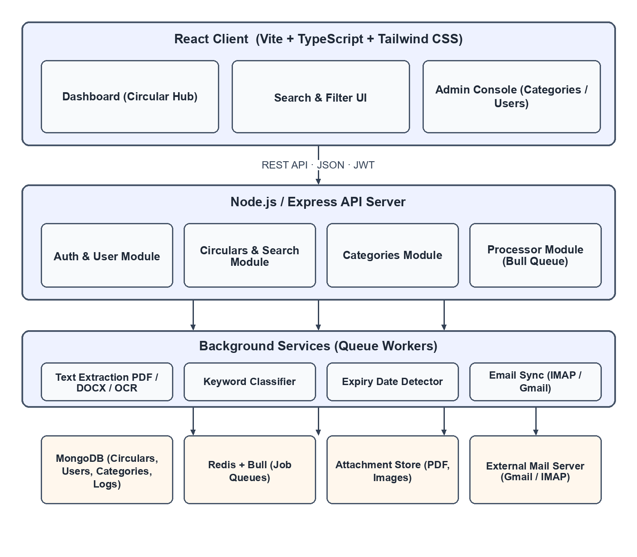
10
5.2 DATA FLOW DIAGRAM
5.2.1 Level 0 DFD
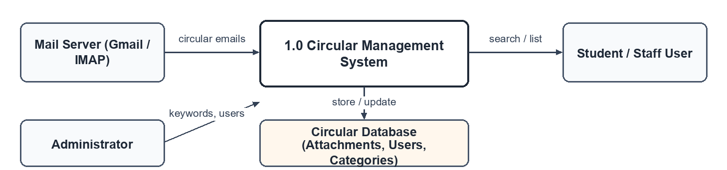
5.2.1 Level 1 DFD
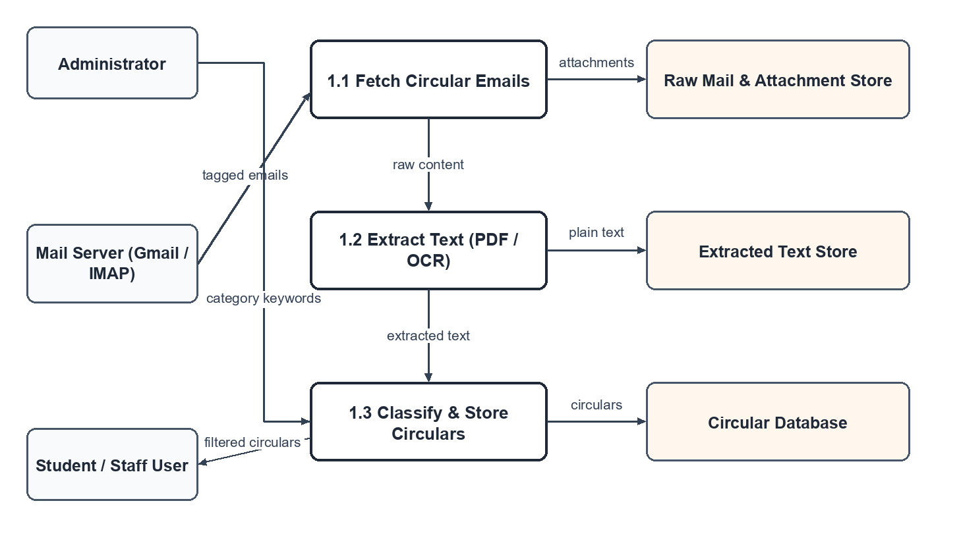
11
5.2.1 Level 2 DFD
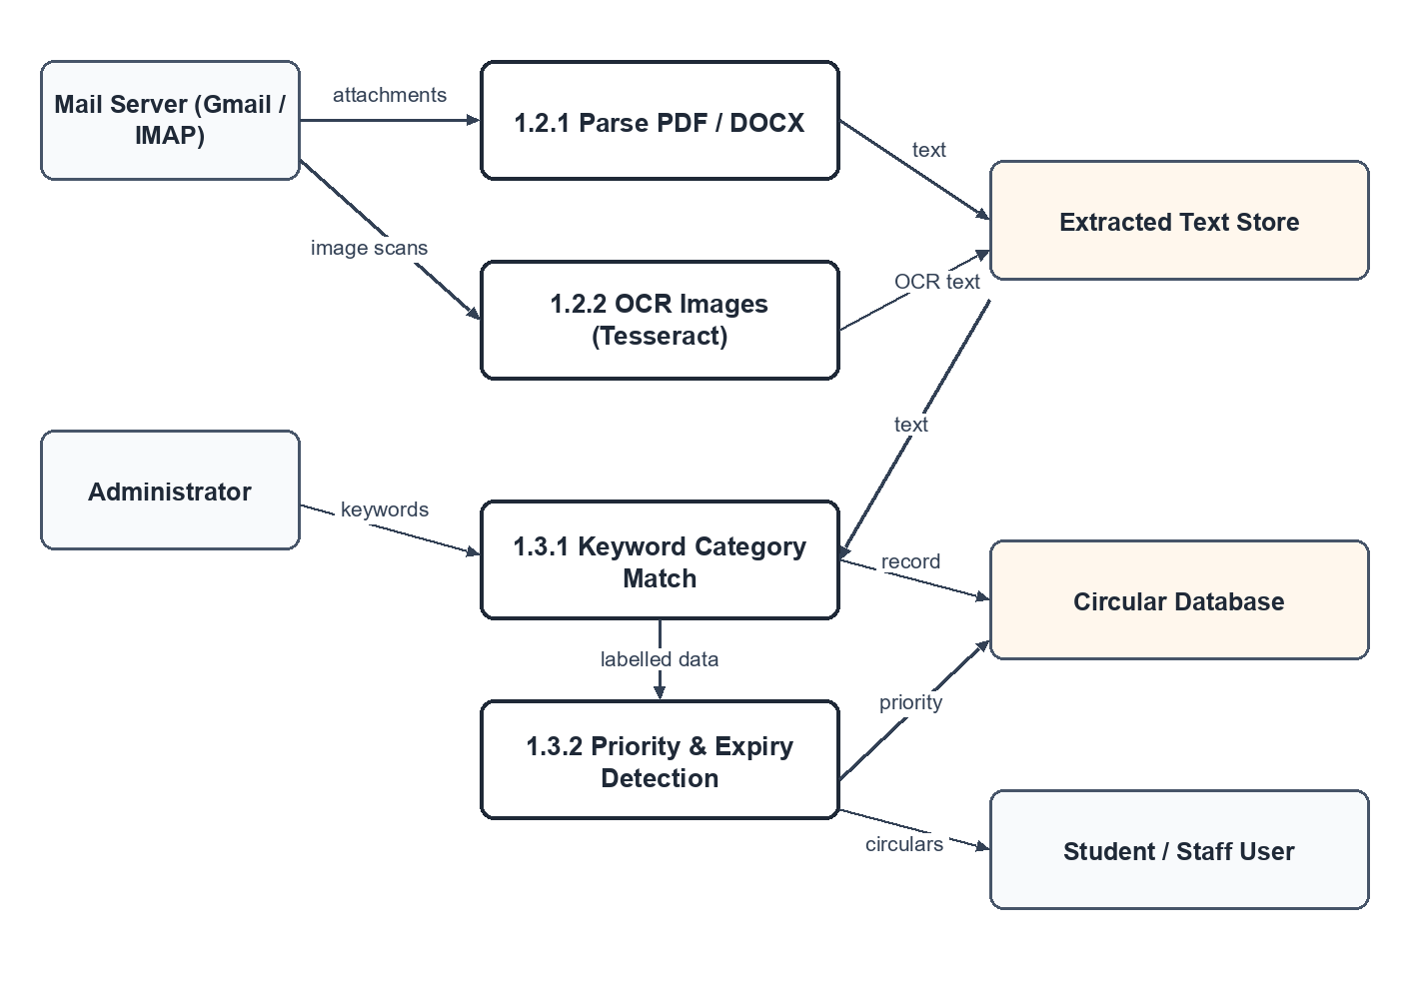
12
5.3 LOGICAL DESIGN USING UML
5.3.1 Usecase Diagram
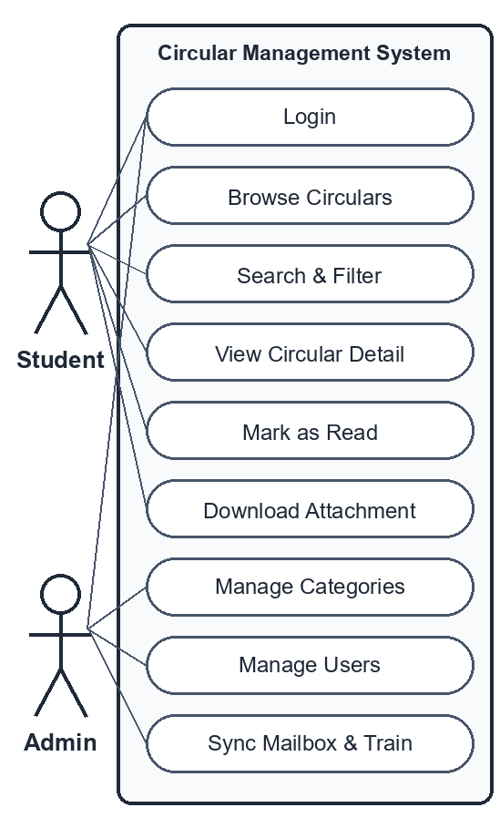
5.4 PHYSICAL DESIGN USING UML
5.4.1 Component Diagram
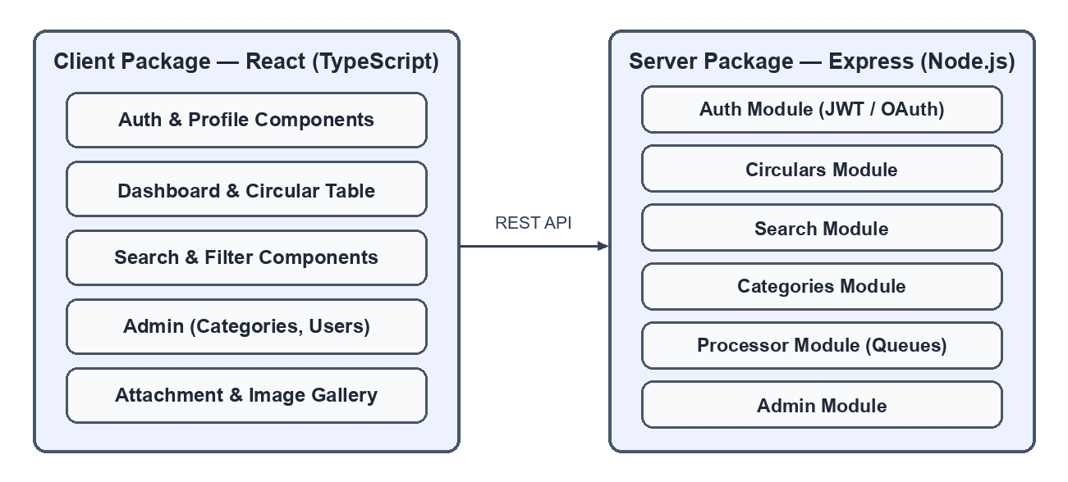
13
5.4.2 Deployment Diagram
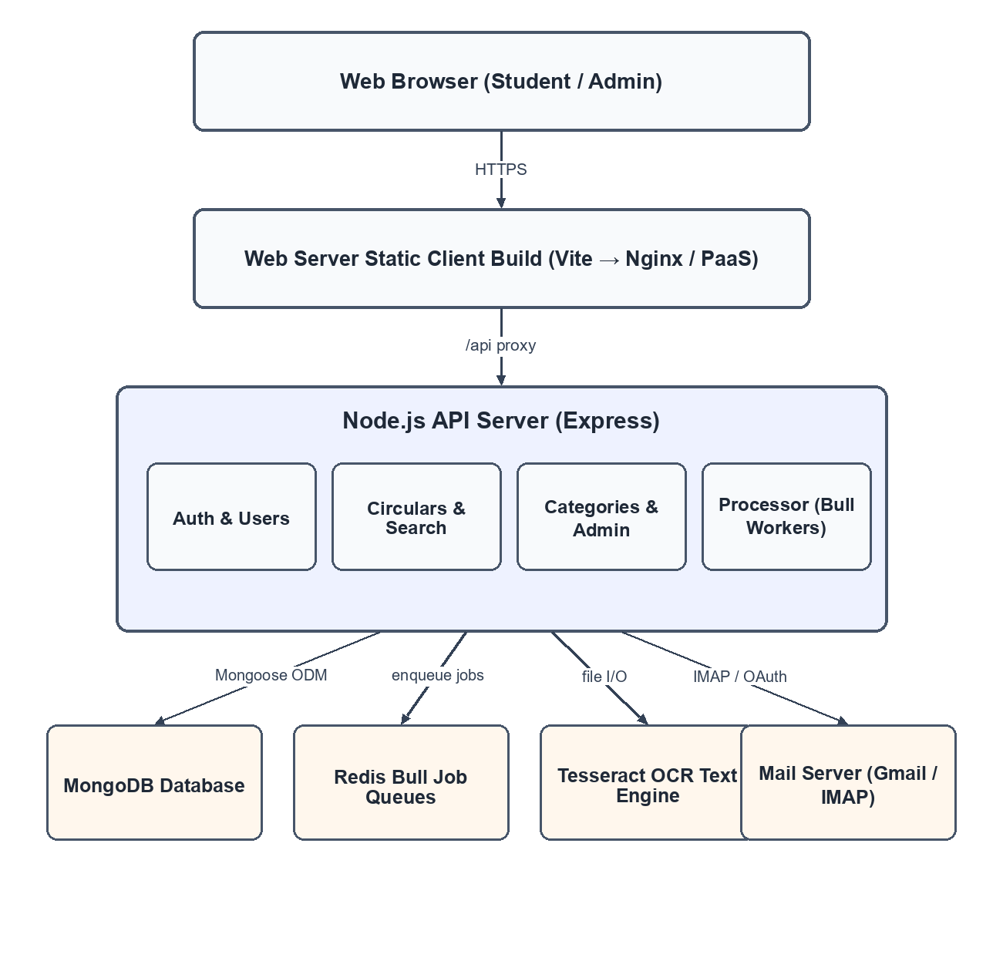
14
6. MODULE DESCRIPTION
6.1 Authentication Module
The authentication and user module handles registration, secure login and
role-based access. Users register with their name, email, department and account
type (Student or Admin), and credentials are protected using hashed passwords and
JSON Web Tokens. The module maintains user profiles and permissions, ensuring
that administrative functions such as managing categories and users are available
only to authorised accounts, while students and staff can view and
search
circulars.
6.2 Dashboard Module
The dashboard, presented as the Circular Hub, is the landing screen after login. It
lists institutional circulars sorted by date and priority and provides quick access to
categories, users and search. A dedicated 'Ending Today' view highlights the
circulars whose deadline is the current day, and summary cards show counts such
as circulars ending today. Filters for sender, category, priority and date range allow
users to narrow the list, making the dashboard a fast, at-a-glance overview of
everything that
requires
attention.
6.3 Circulars Module
This module manages the complete life cycle of a circular, from ingestion to
display. Circulars received from the mail server or uploaded manually are stored
with their title, category, priority, sender, tags, received date and due date. Users
can open a detailed view that shows the full content, attachment, extracted
important dates and the classification result, and administrators can edit, archive or
delete circulars, ensuring that the repository always reflects the current state of
institutional communication.
6.4 Email & OCR Module
This module fetches circulars automatically from the configured institutional mail
server using IMAP and also accepts manual uploads of PDF, DOCX and image
files. Email bodies are parsed, and attachments are processed by PDF and DOCX
text extractors. Scanned documents and images are passed through the Tesseract
OCR engine to recover their text. Extracted content is normalised and queued for
classification and expiry detection, so that even image-based notices become
fully
searchable.
15
6.5 Classification Module
The keyword classification module assigns each circular to a category
automatically. Each category, such as Examinations, Academic, Placements,
Holidays, Events or Administration, is defined with a set of keywords and phrases.
When a circular is processed, the module scores it against these keyword sets and
selects the best-matching category, storing the confidence and the matched terms.
Administrators can add or edit categories and keywords from the admin console, so
classification can be tuned to the institution's own vocabulary without any code
changes.
6.6 Expiry Alerts Module
The expiry date detection module scans the extracted text for dates and deadline
phrases and derives a due date for each circular. It then computes the number of
days remaining and flags circulars that are expiring today or within a short
window. These flags drive the 'Ending Today' view and the due-date column on
the dashboard, helping users act on time-critical announcements. Validity
information is also shown on the detailed circular view so that outdated notices are
not mistaken for current ones.
6.7 Search Module
The search and filter module provides instant keyword search across all circulars,
with the option to filter by category, priority, tag, sender and date range. Results
are ranked and displayed with their category, priority level and received date. This
module allows a user to locate a specific circular within seconds even when the
repository contains hundreds of notices, combining full-text matching with
structured filters for accurate results.
6.8 Admin Module
The admin console gives administrators control over the system configuration and
users. It includes category management, where categories and their keywords are
created and edited, and user management, where accounts are listed with their role,
department and join date. Changes made in the console immediately affect how
new circulars are classified, making the console the operational heart of the
system.
6.9 Attachments Module
The attachment and storage module manages circular attachments. Attachments
such as PDF and image files are stored securely and linked to their circulars, and
all records including circulars, users, categories and processing logs are persisted in
MongoDB. This module guarantees data integrity and provides the reliable
foundation on which search, display and administration depend.
16
7. RESULTS AND IMPLEMENTATION
RESULTS
The Circular Classifier project delivered a robust, automated platform for
managing institutional circulars. The results achieved are as
follows:
1. Interactive and User-Friendly Interface:
○ The dashboard presents circulars in a clean, sorted layout that is easy
to scan and navigate.
○ Users can reach any circular, category or filter within a few clicks,
improving overall engagement.
2. Automated Circular Ingestion:
○ Circulars are fetched automatically from the configured mail
server and from uploaded documents and attachments.
○ Circulars are classified into categories with keyword matching and
ranked by priority.
3. Automatic Classification:
○ Expiry detection flags circulars that are ending today or soon.
4. Expiry and Priority Alerts:
○ Priority levels help users focus on the most urgent notices
first.
○ Automated processing removes the repeated manual effort of sharing
notices.
17
5. Instant Search and Filters:
○ A powerful search lets users find circulars by keyword, category,
priority, tag, sender or date.
○ Results are ranked and displayed with their key details for quick
decisions.
6. Responsive and Cross-Device Compatibility:
○ The application works well on desktops, tablets and mobile devices.
○ Ensures consistent performance and appearance across different
screen sizes.
7. Professional Deployment:
○ The application is deployed on a cloud platform with managed
database and queue services.
○ Provides a secure, reliable and always-available service to the
institution.
Overall Outcome: The project successfully achieved its objective of
creating an automated, searchable and priority-aware system
that improves how institutions communicate with students and staff.
Implementation Process
The development of the Circular Classifier was completed in a structured and
systematic approach, as described below:
1. Project Planning:
○ Defined the scope, objectives and target users.
○ Identified critical features: circular ingestion, extraction,
classification, expiry detection and search.
○ Prepared a timeline and allocated tasks to ensure timely completion.
18
2. System Design:
○ Designed the navigation structure and data model for intuitive use.
○ Planned the user interface and defined the categories and priority
rules.
3. Development:
○ Implemented the client using React with a modular, component-based
architecture for maintainability and
scalability.
○ Styled the interface with Tailwind CSS for a modern, responsive
layout.
○ Built the Express REST API and background workers for ingestion,
OCR, classification and expiry detection.
○ Stored circulars, users, categories and logs in MongoDB using clear
models.
○ Optimized the application for performance and fast loading across
devices.
4. Testing:
○ Functional Testing: Verified ingestion, classification, search and
admin features.
○ Design Testing: Checked layout consistency and responsiveness
across devices and browsers.
○ Identified and resolved minor issues before deployment to ensure
smooth operation.
5. Deployment:
○ Deployed the tested application on a cloud platform with managed
services.
19
○ Configured the environment variables and mail-server settings for the
institution.
○ Verified live performance, background processing and secure access
for users.
LOGIN PAGE :
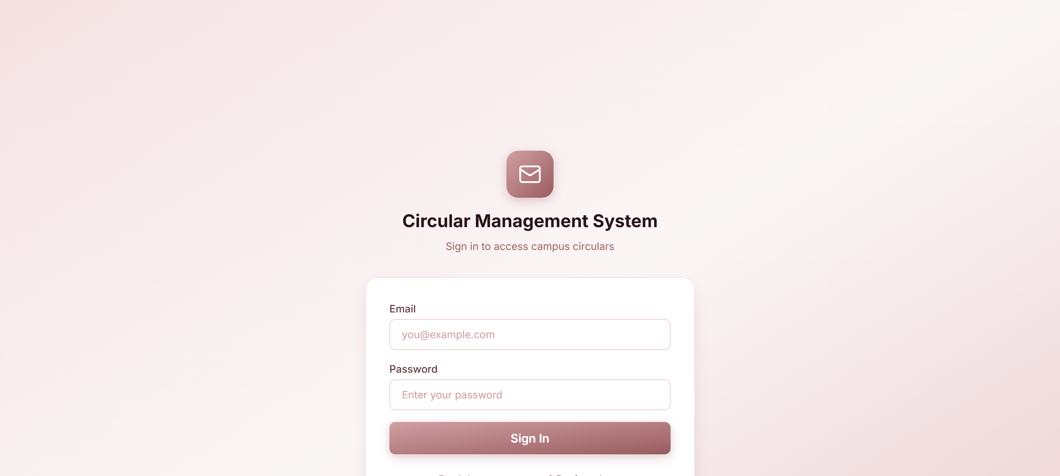
REGISTRATION :
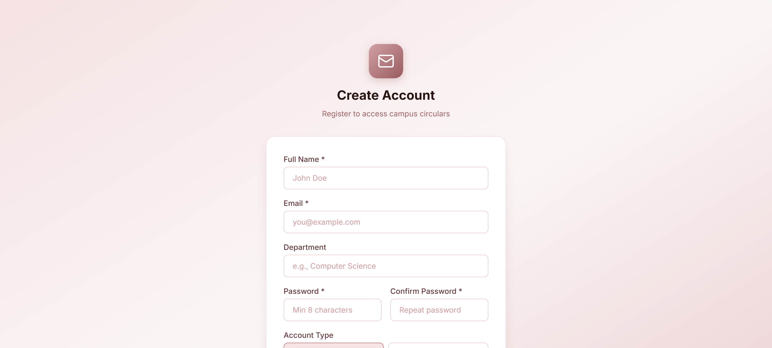
20
DASHBOARD :
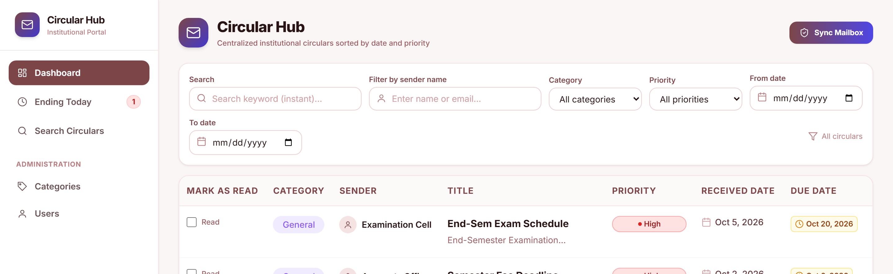
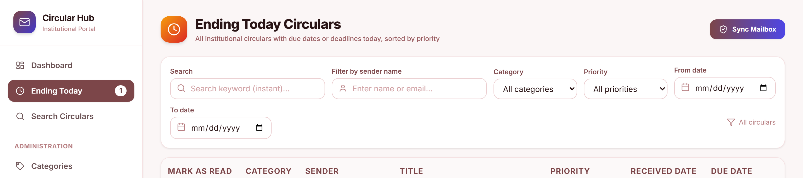
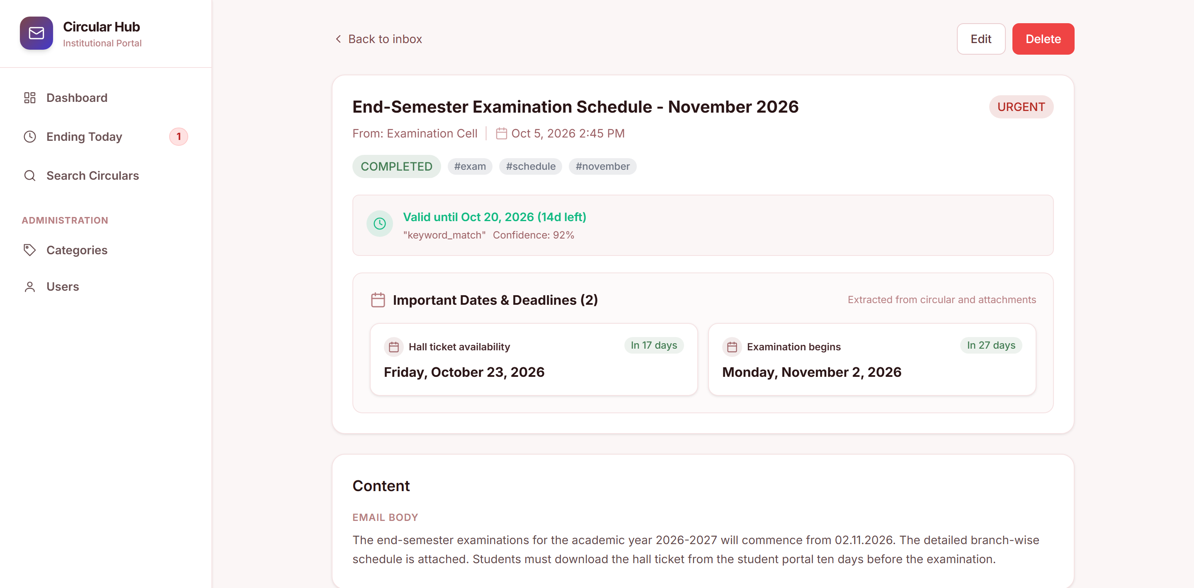
21
ATTACHMENT VIEW :
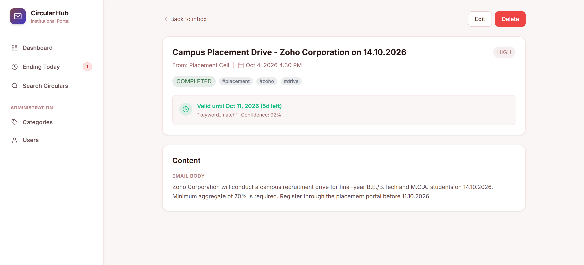
SEARCH & ADMIN :
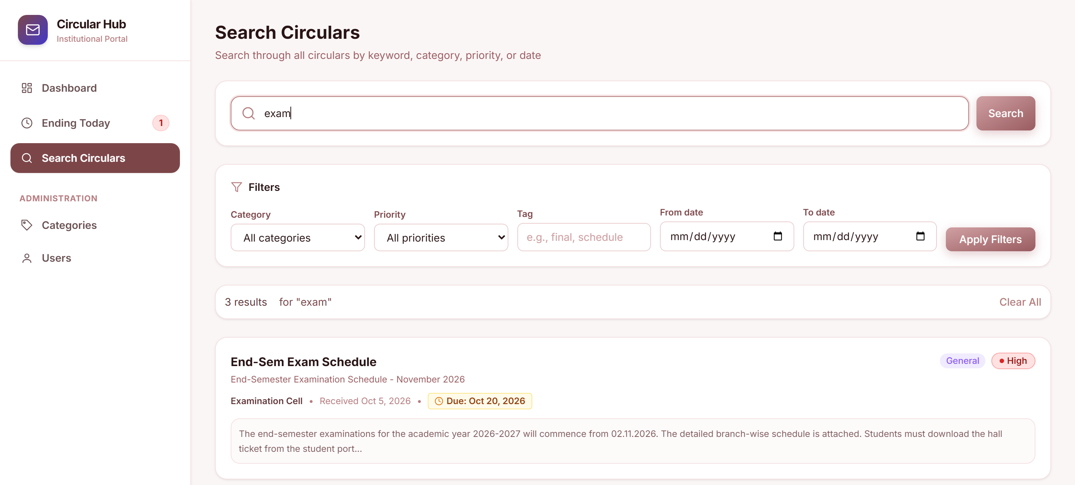
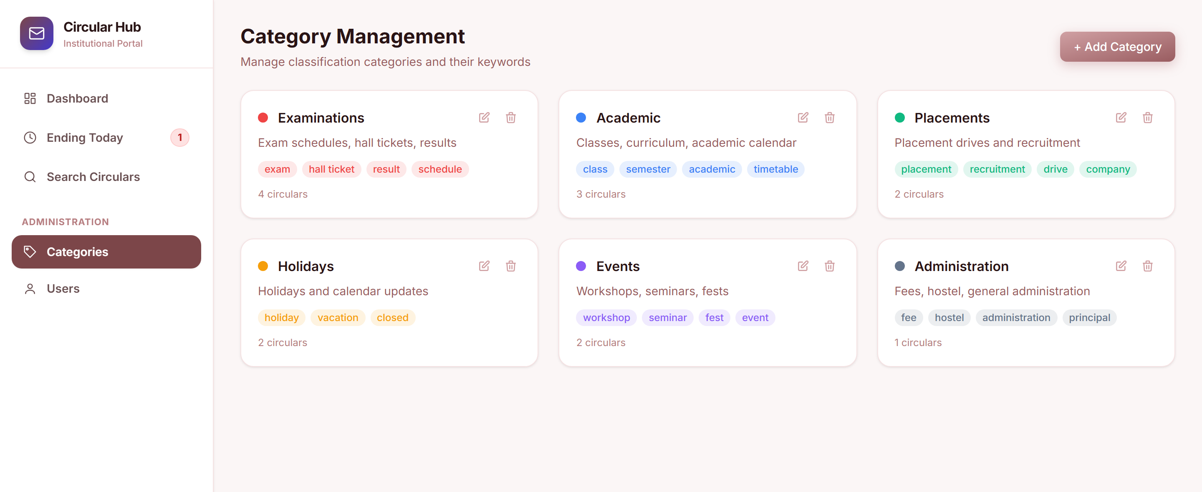
22
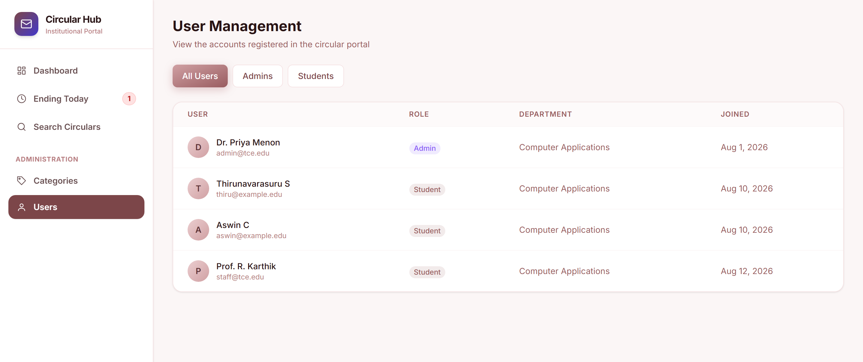
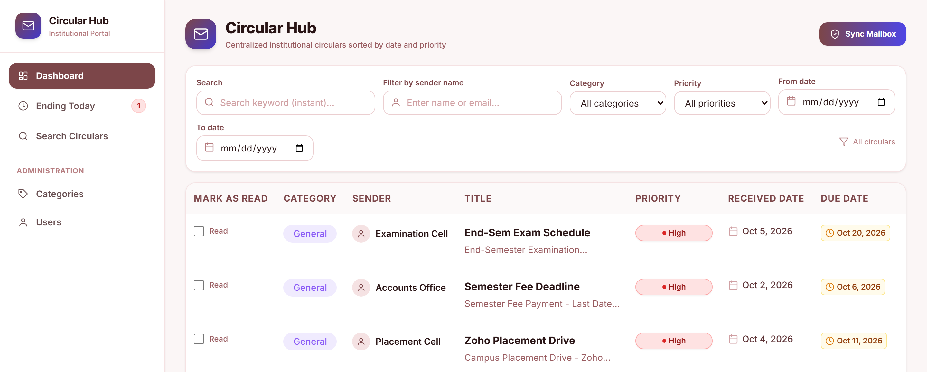
CIRCULAR DETAILS :
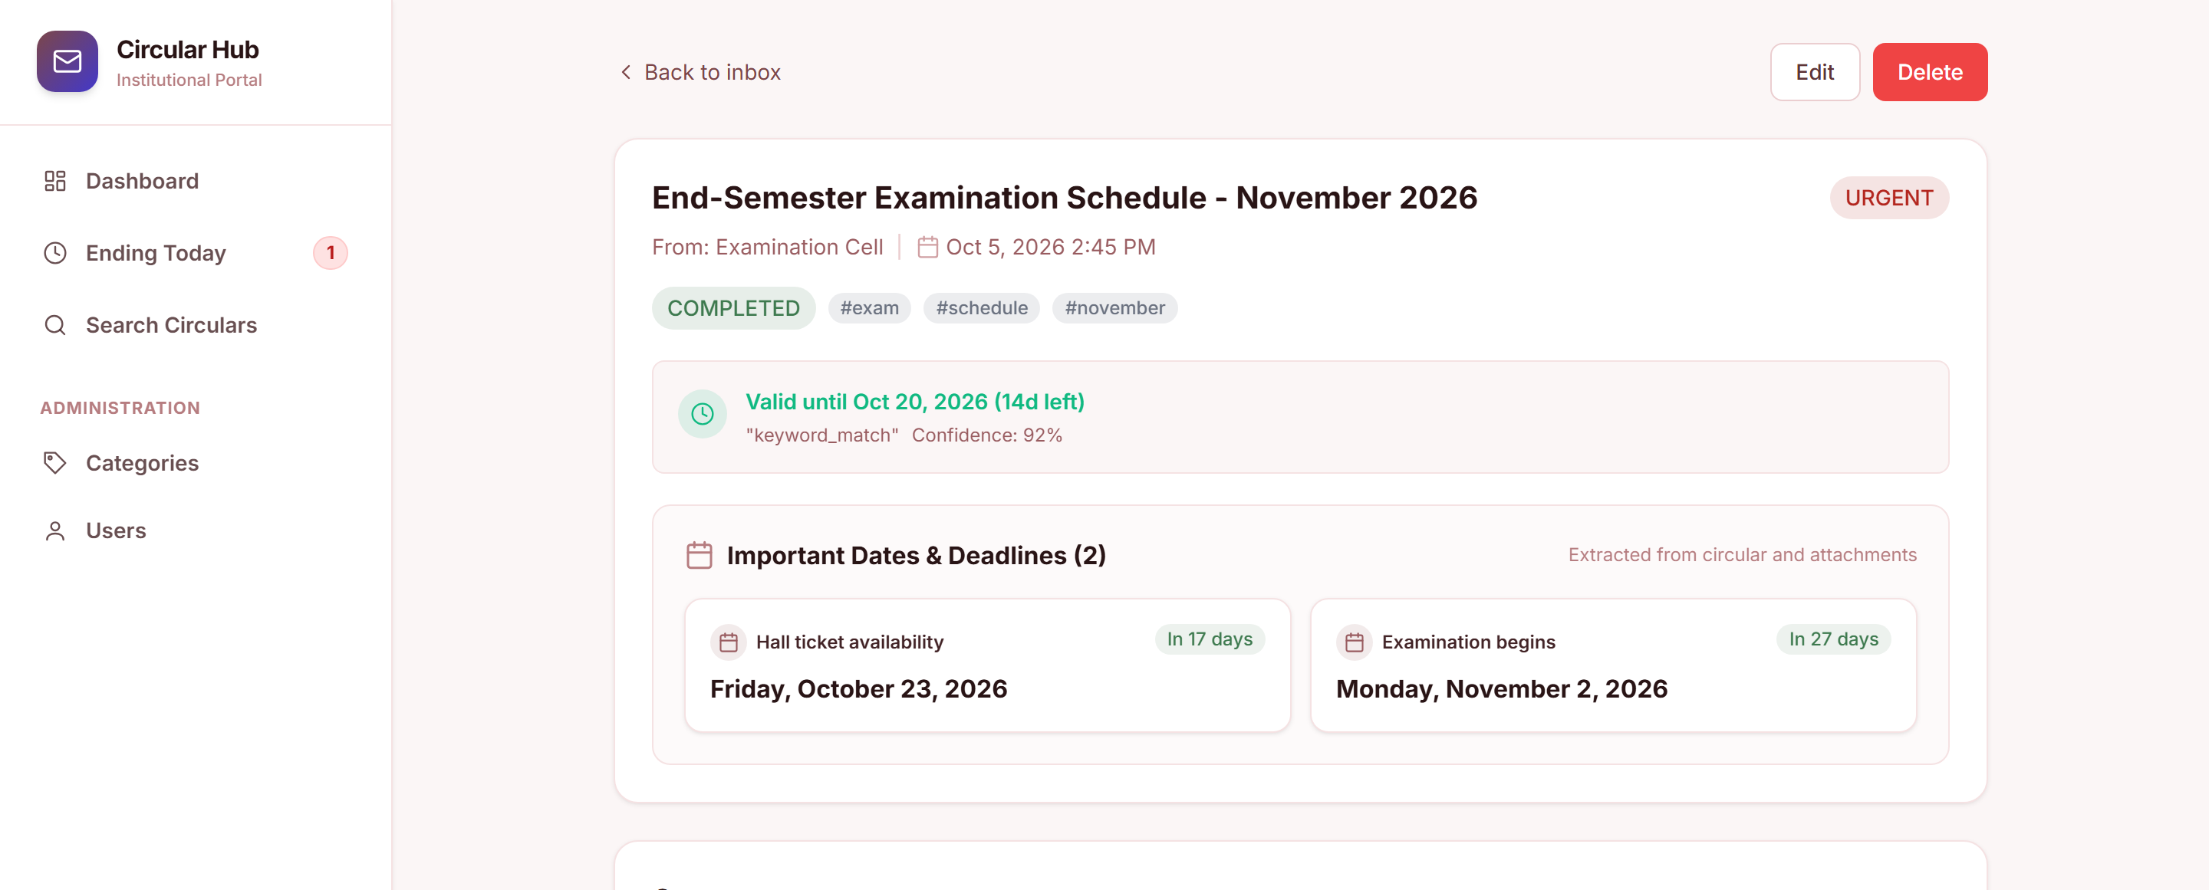
23
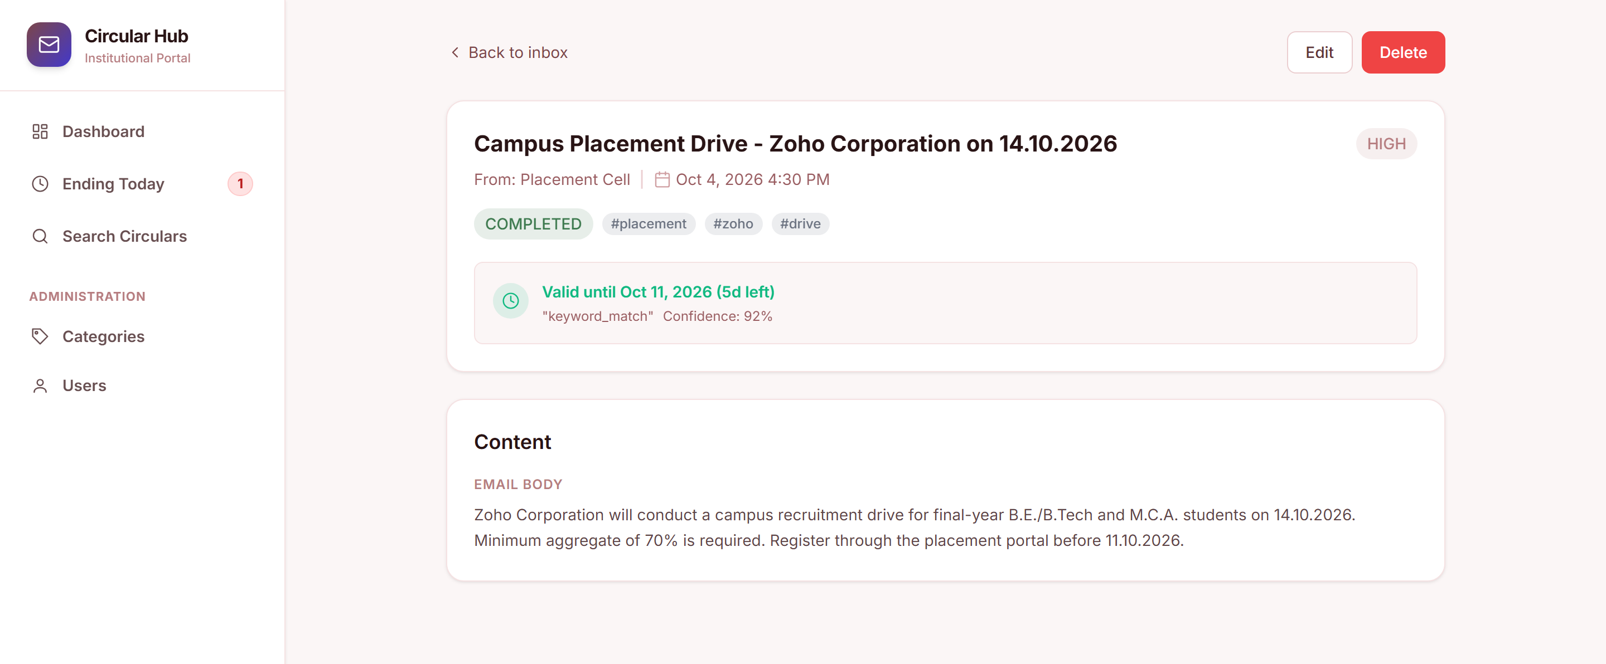
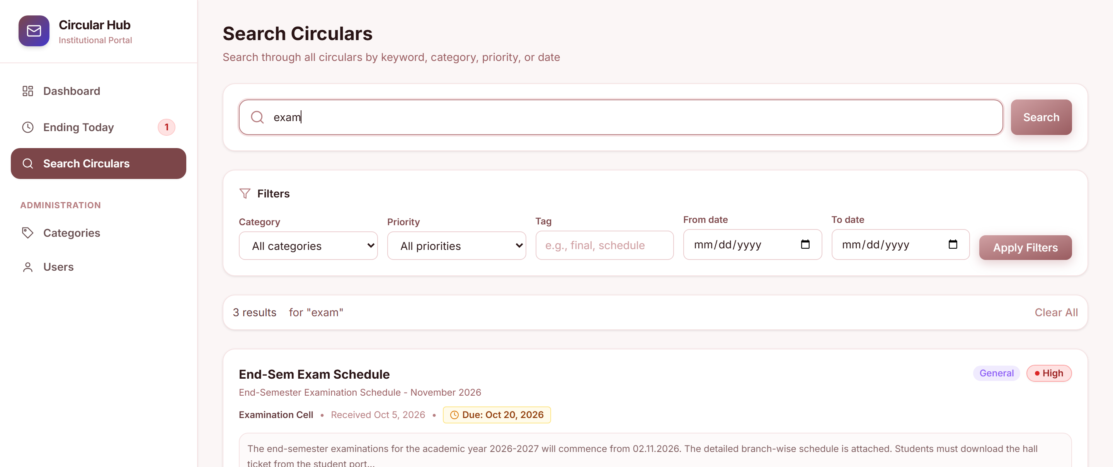
EXPIRY ALERTS :
Implementation Summary: Through careful planning, systematic design, rigorous
testing and cloud deployment, the Circular Classifier project successfully delivered
a robust, reliable and user-centric platform that meets the institution's
requirements and improves communication and engagement.
24
8. CONCLUSION
The Circular Classifier project has been a successful endeavour in delivering an
automated, searchable and user-centric platform for institutional circulars. The
project achieved all its primary objectives, providing both functional and practical
value to students, staff and administrators.
Key points of the conclusion include:
1. Successful Deployment:
○ The application was successfully deployed on a cloud platform with
managed database and queue services.
professional and always-available service.
○ Live deployment ensures that circulars are accessible to users across
the institution at any time.
2. User Feedback and Iteration:
○ The system was well received by students and staff, who continue to
provide feedback for further improvements.
○ Continuous feedback allows iterative updates, ensuring the platform
evolves according to user needs.
3. Enhanced User Experience:
○ The dashboard, instant search and filters make it easy to find and track
circulars.
○ Users can explore circulars, categories and deadlines seamlessly,
improving awareness of important announcements.
announcements.
25
4. Comprehensive Circular Repository:
○ A centralized repository captures circulars from email and uploads
and classifies them automatically for easy
retrieval.
○ Search, filters and expiry alerts help users make informed and timely
decisions.
5. Accessibility & Responsiveness:
○ The platform is fully responsive and optimized for desktops, tablets
and mobile devices.
○ Accessibility features, such as clear labels and keyboard navigation,
ensure a wider reach and inclusivity.
6. Modern Technology Stack:
○ Using React, Node.js, MongoDB and Redis allowed for a scalable
and maintainable application.
○ The modular architecture enables easy updates, new categories and
future scalability.
7. Testing & Quality Assurance:
○ The project underwent rigorous functional and design testing,
ensuring reliable performance and eliminating errors before
deployment.
Overall, the Circular Classifier project stands as a successful implementation of
modern full-stack development practices, meeting institutional requirements and
delivering a platform that is functional, reliable, accessible and scalable. It not only
centralizes institutional communication but also provides a strong base for
continuous improvement, with user feedback driving future
enhancements.
26
9.BIBILOGRAPHY
1. React Documentation – Official documentation for the React library.
https://react.dev
2. Node.js and Express Documentation – Guides for building REST APIs with
Node.js and Express. https://nodejs.org/docs
3. MDN Web Docs – HTML, CSS and JavaScript – Reference for core web
technologies.
https://developer.mozilla.org
4. MongoDB Documentation – Guides for data modelling and queries with
MongoDB and Mongoose.
https://www.mongodb.com/docs
5. Redis and Bull Documentation – For background job queues and
asynchronous processing. https://docs.bullmq.io
6. Tesseract OCR Documentation – For extracting text from images and
scanned documents. https://tesseract-ocr.github.io
7. Tailwind CSS Documentation – For utility-first styling and responsive
design. https://tailwindcss.com/docs
8. Project Requirement Documents – Internal project documentation prepared
by the team for the Circular
Classifier.
27
10. APPENDICES
10.1 APPENDIX - A PROJECT SCREENSHOTS
LOGIN & DASHBOARD :
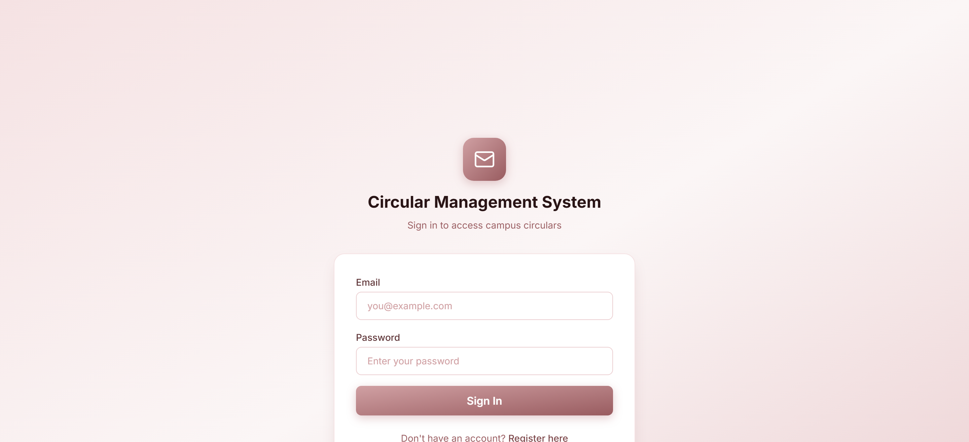
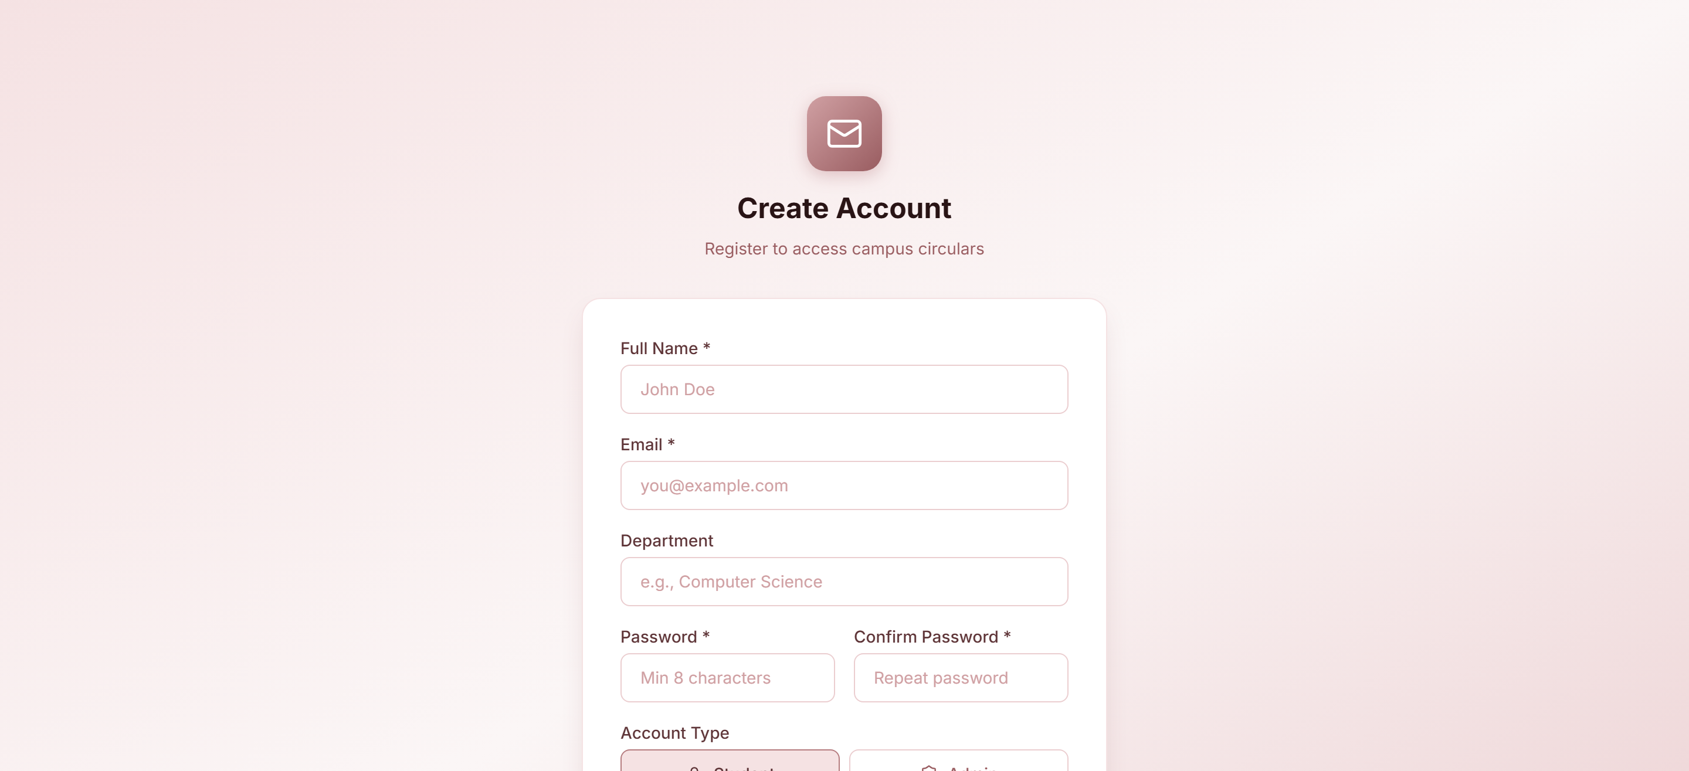
28
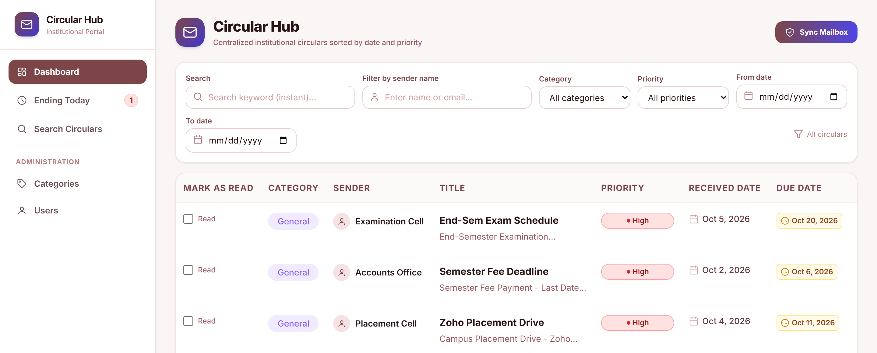
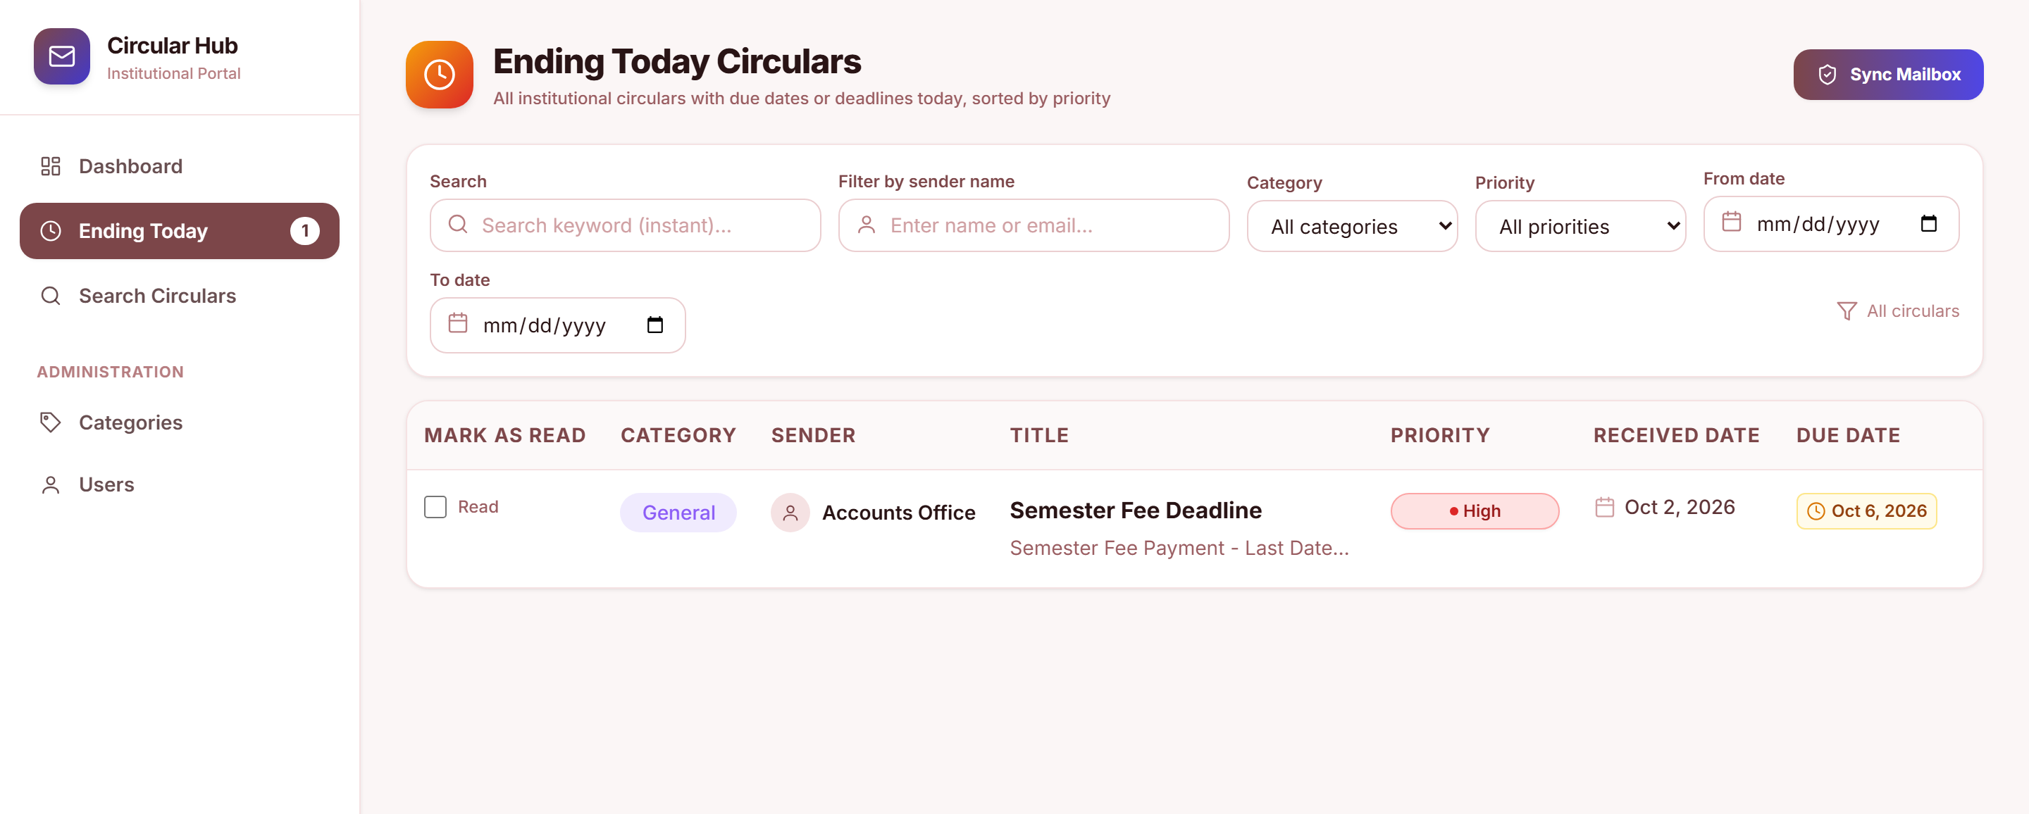
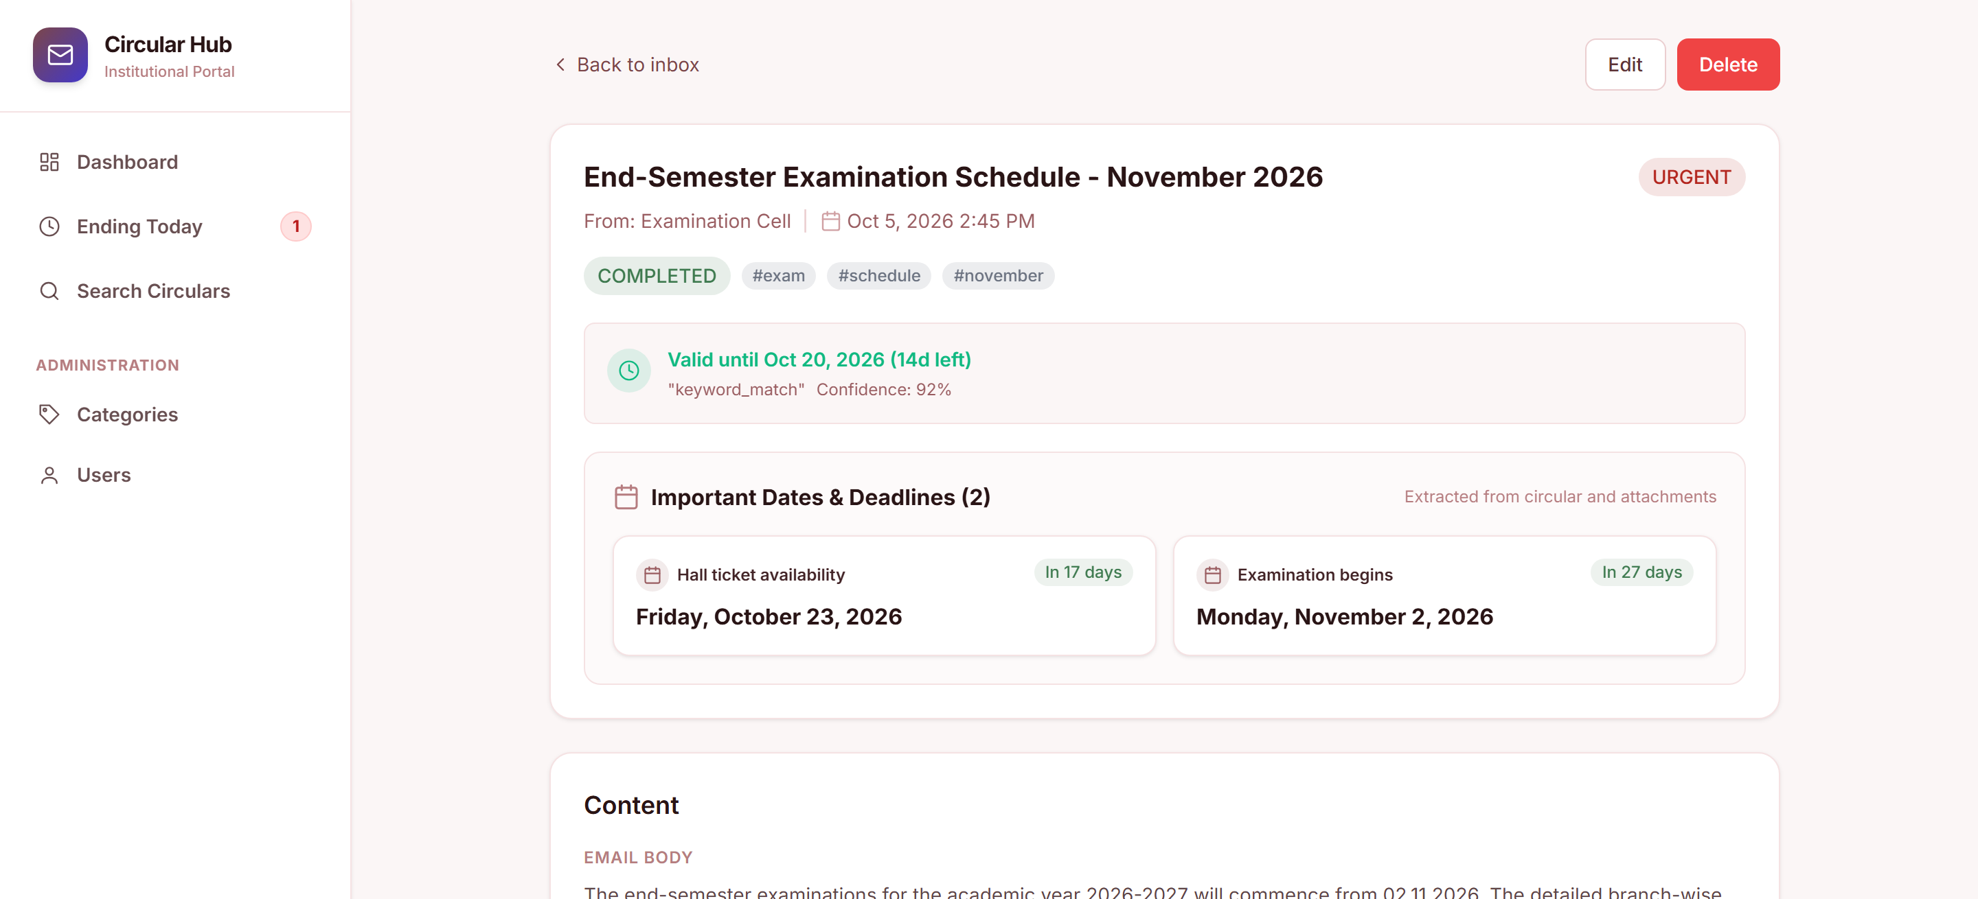
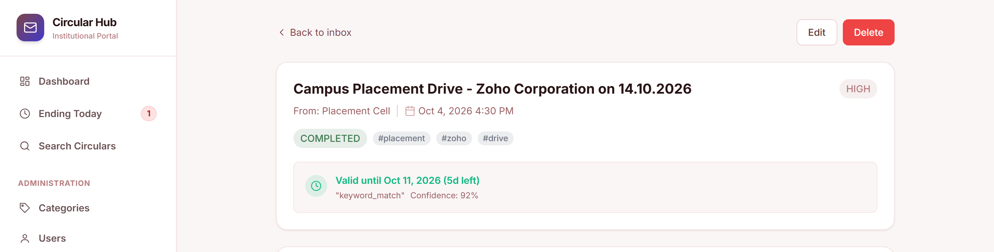
29
SEARCH & ADMIN :
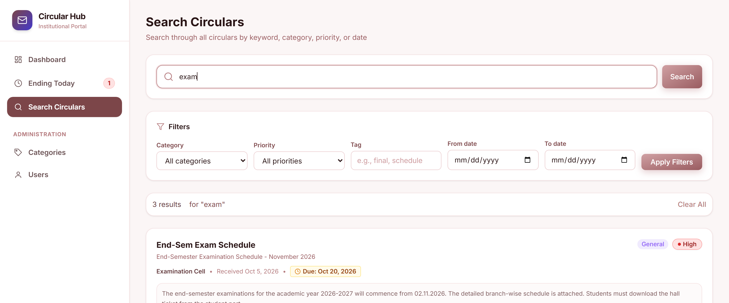
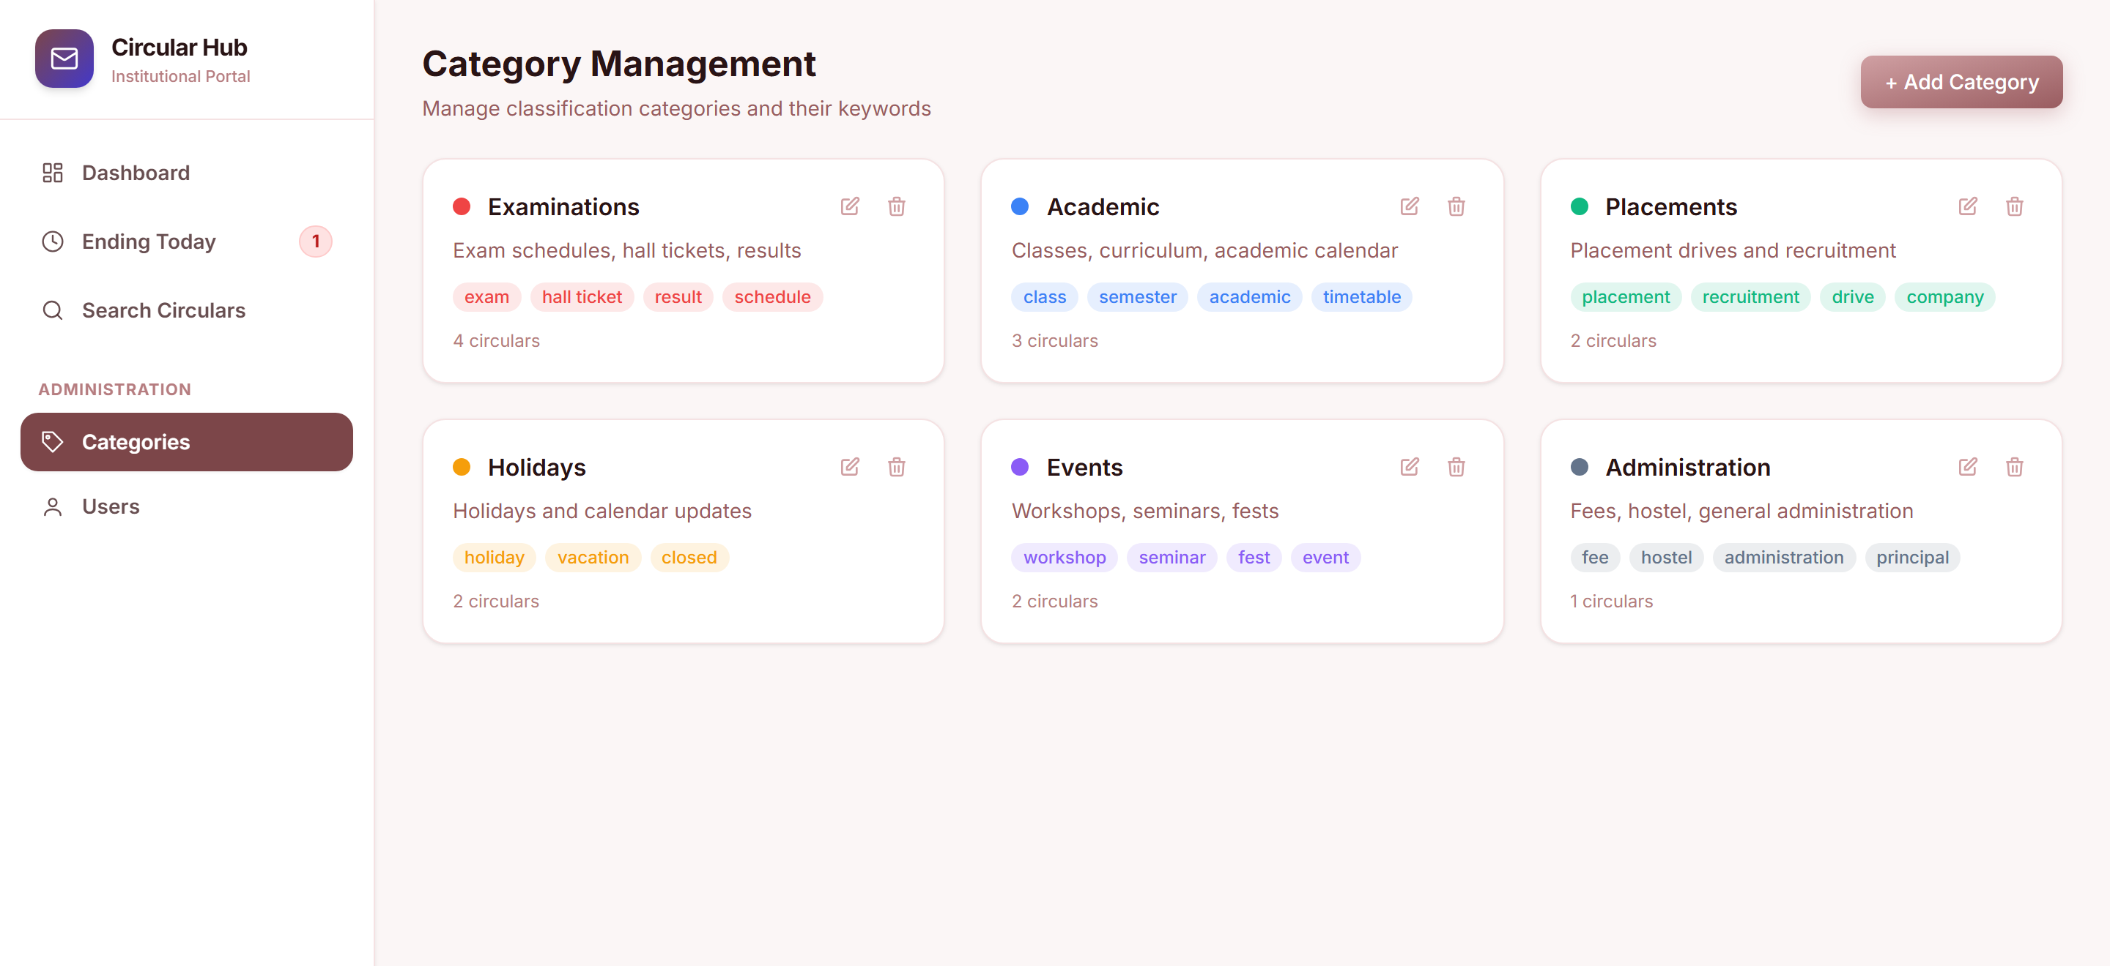
30
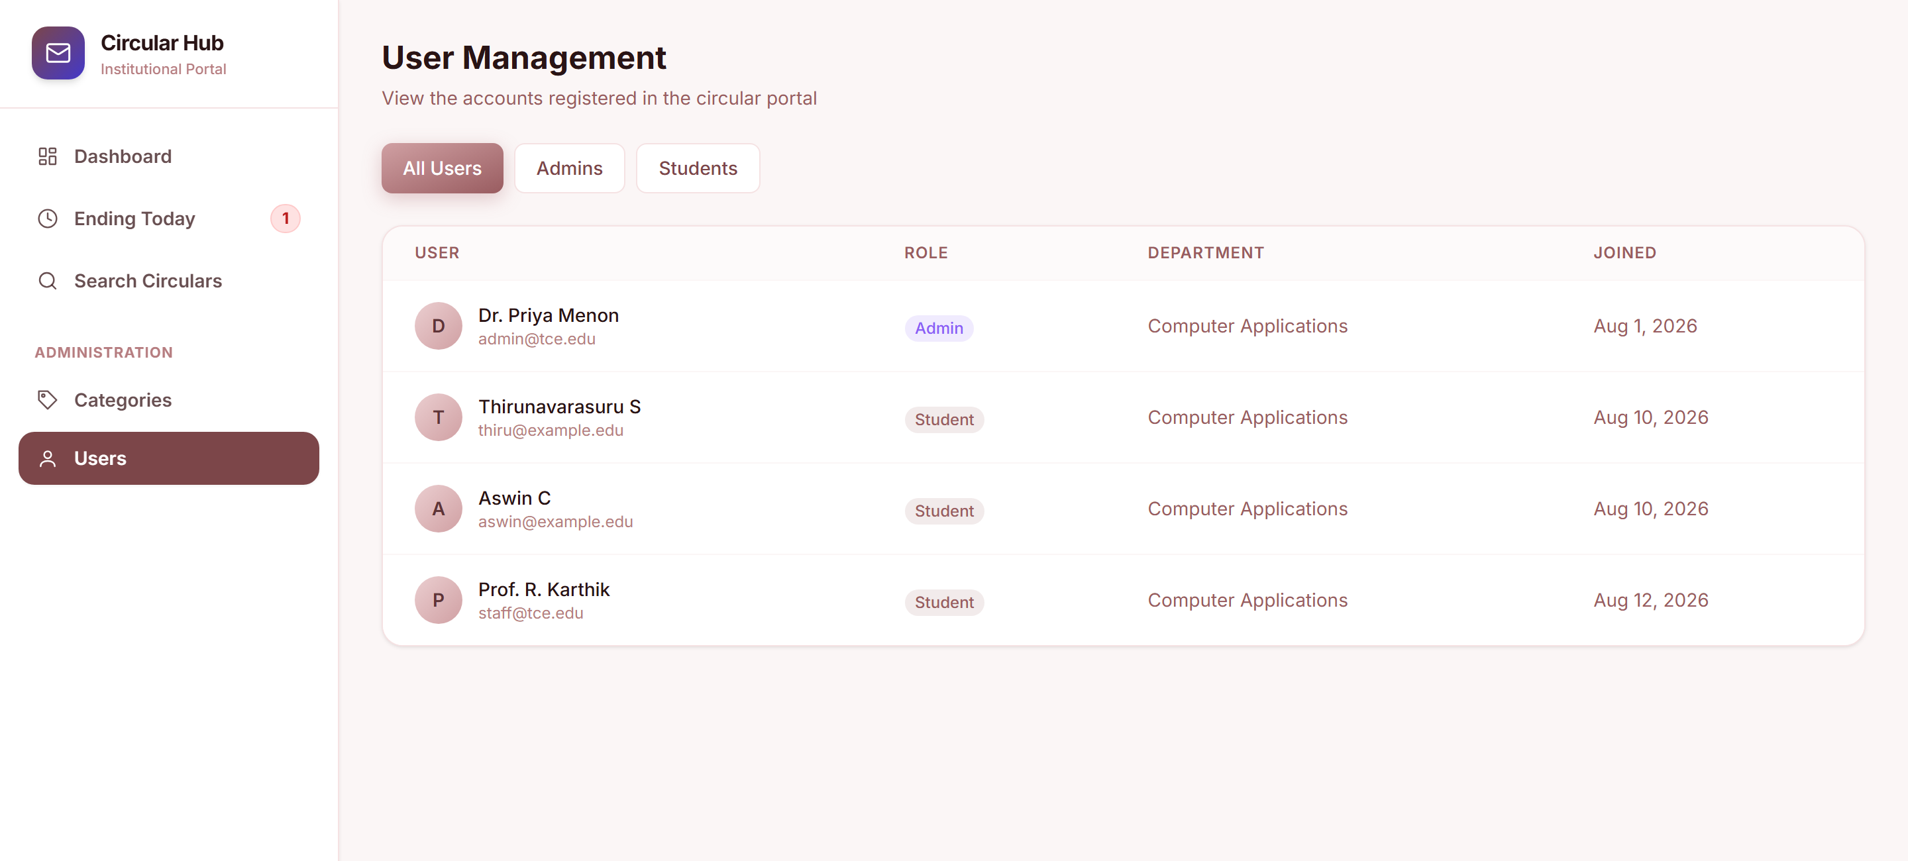
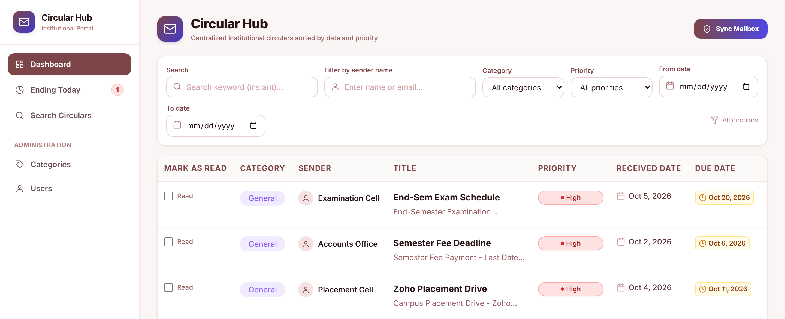
EXPIRY, DETAIL & SEARCH :
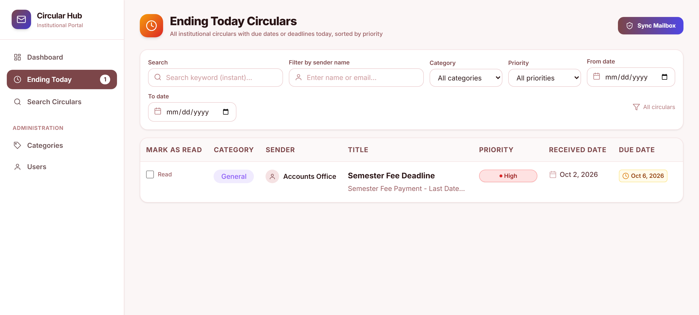
31
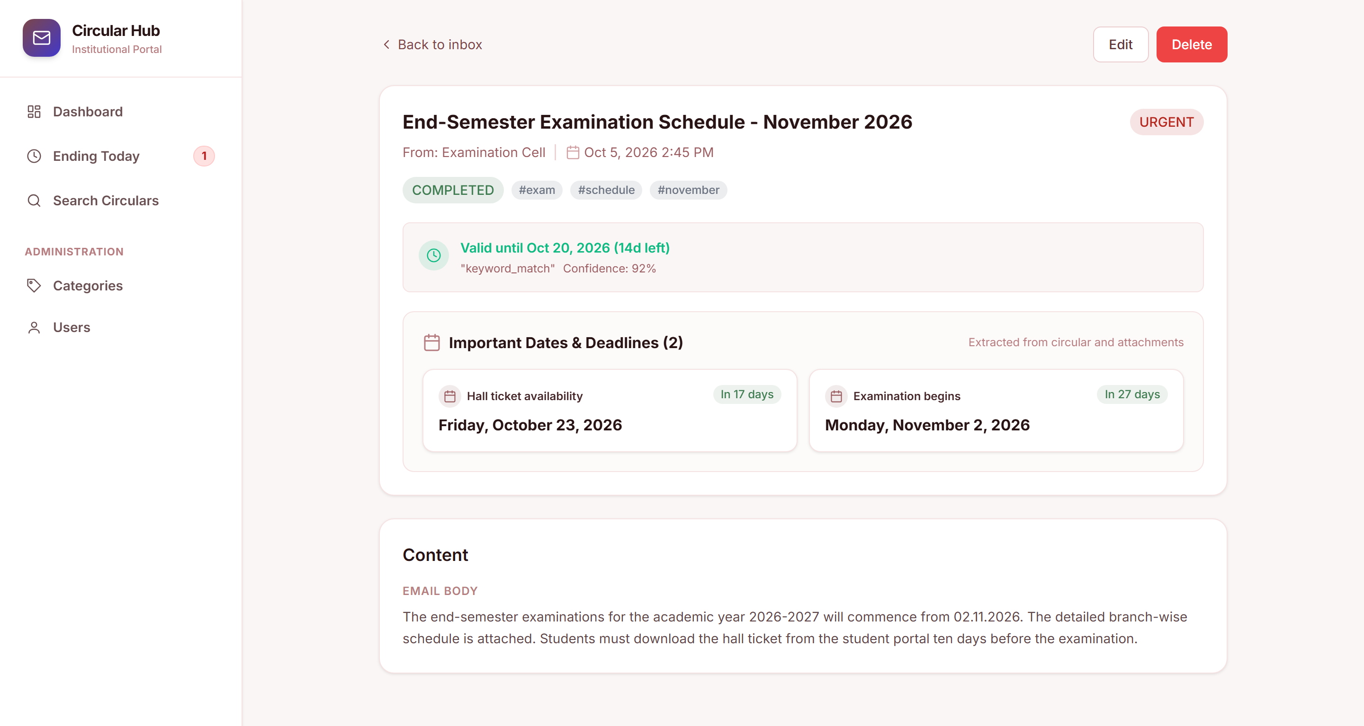
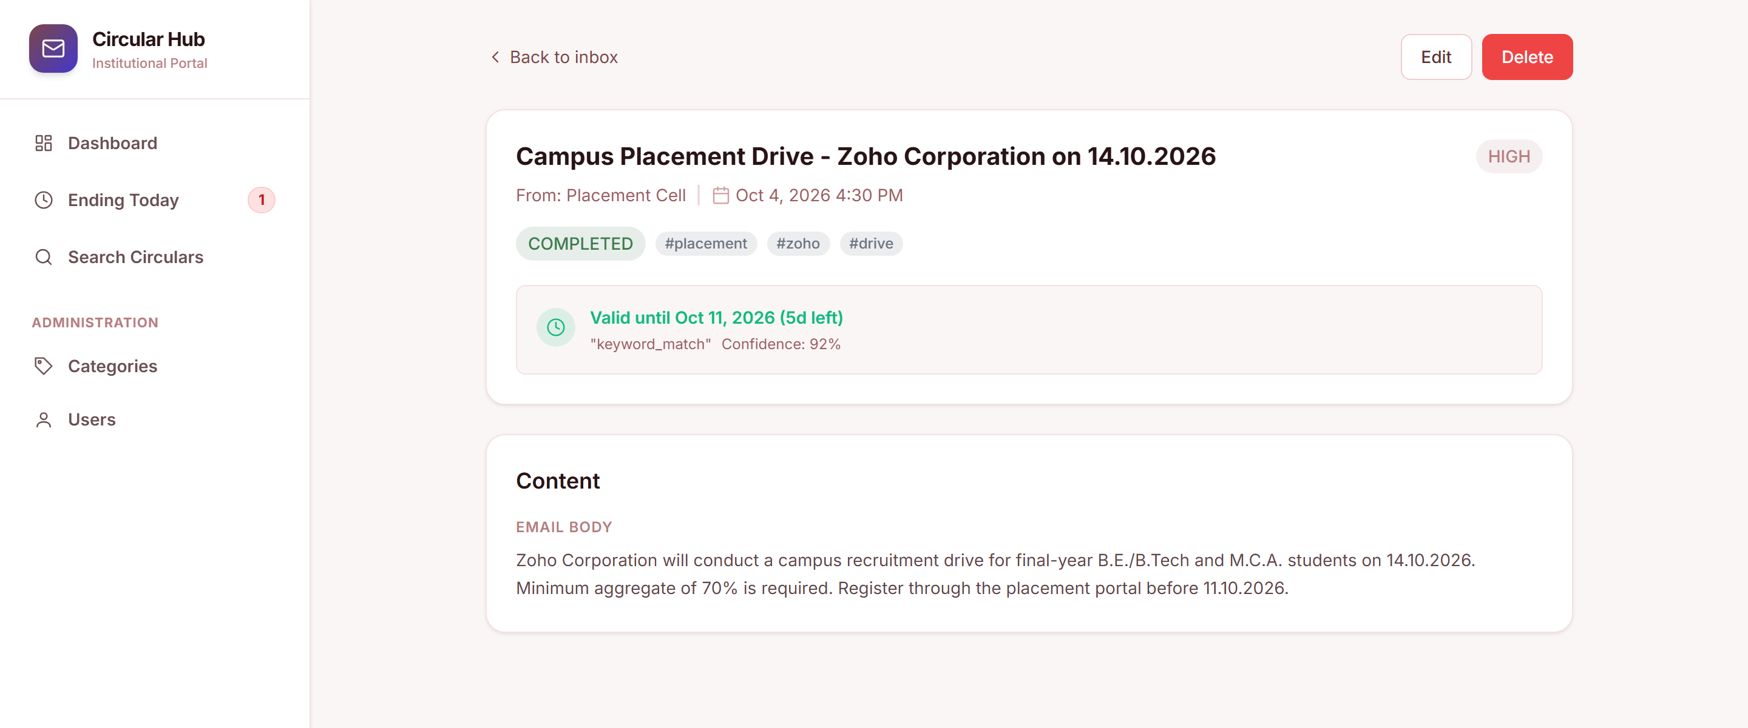
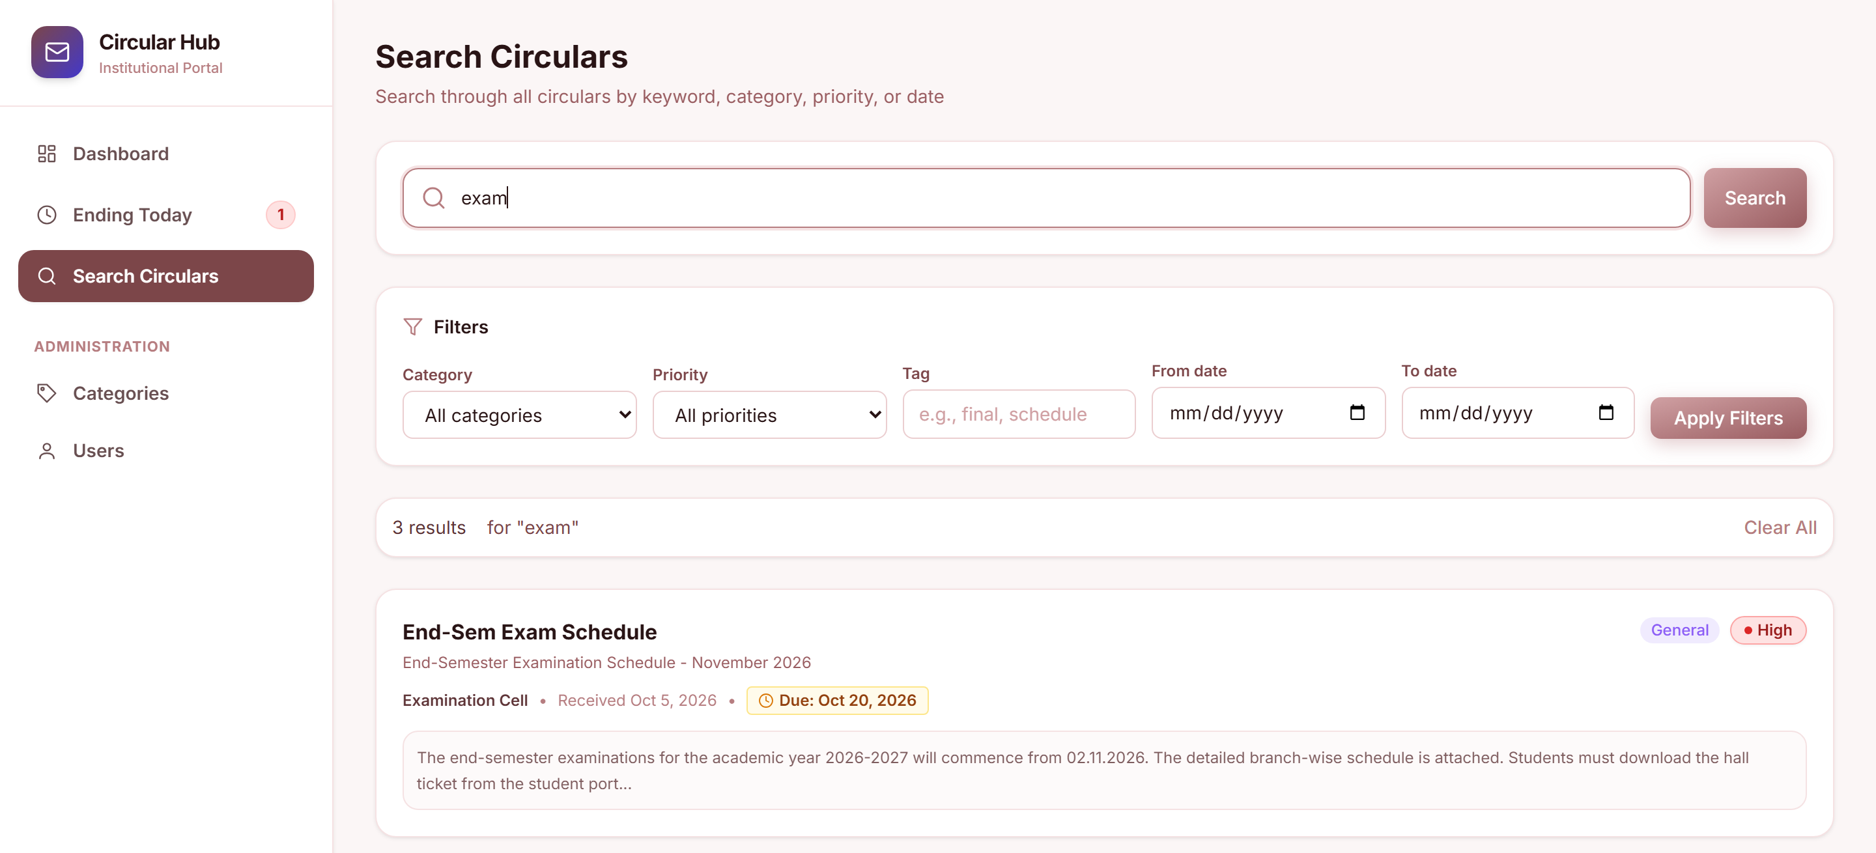
32
ADMIN & LOGIN :
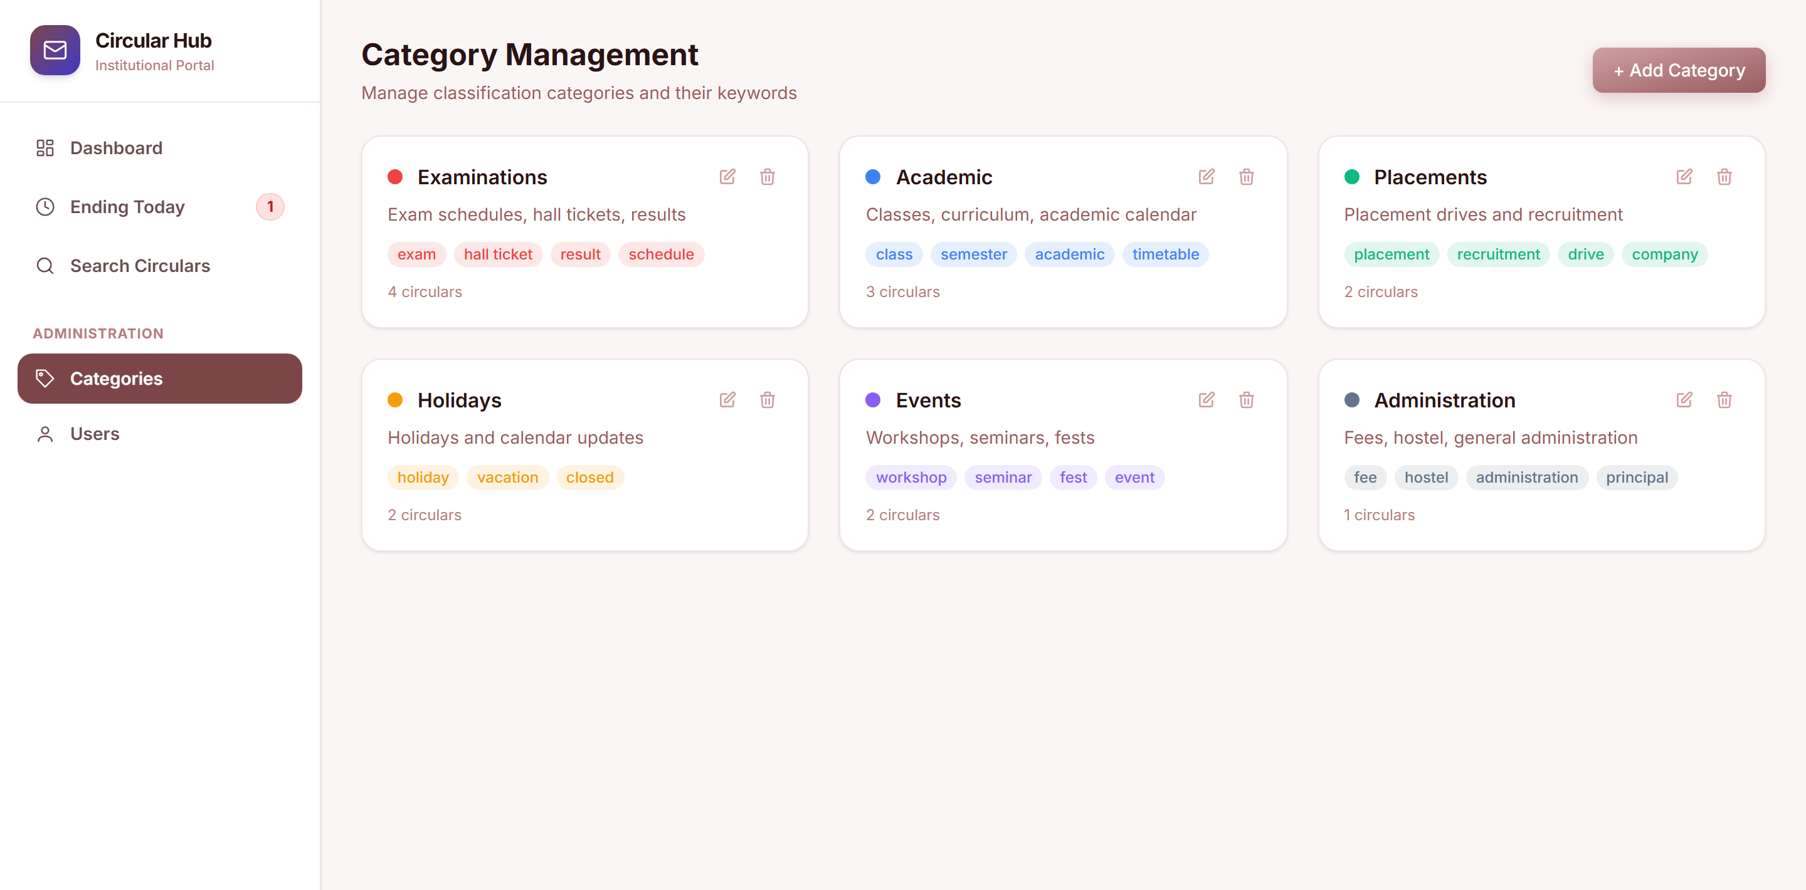
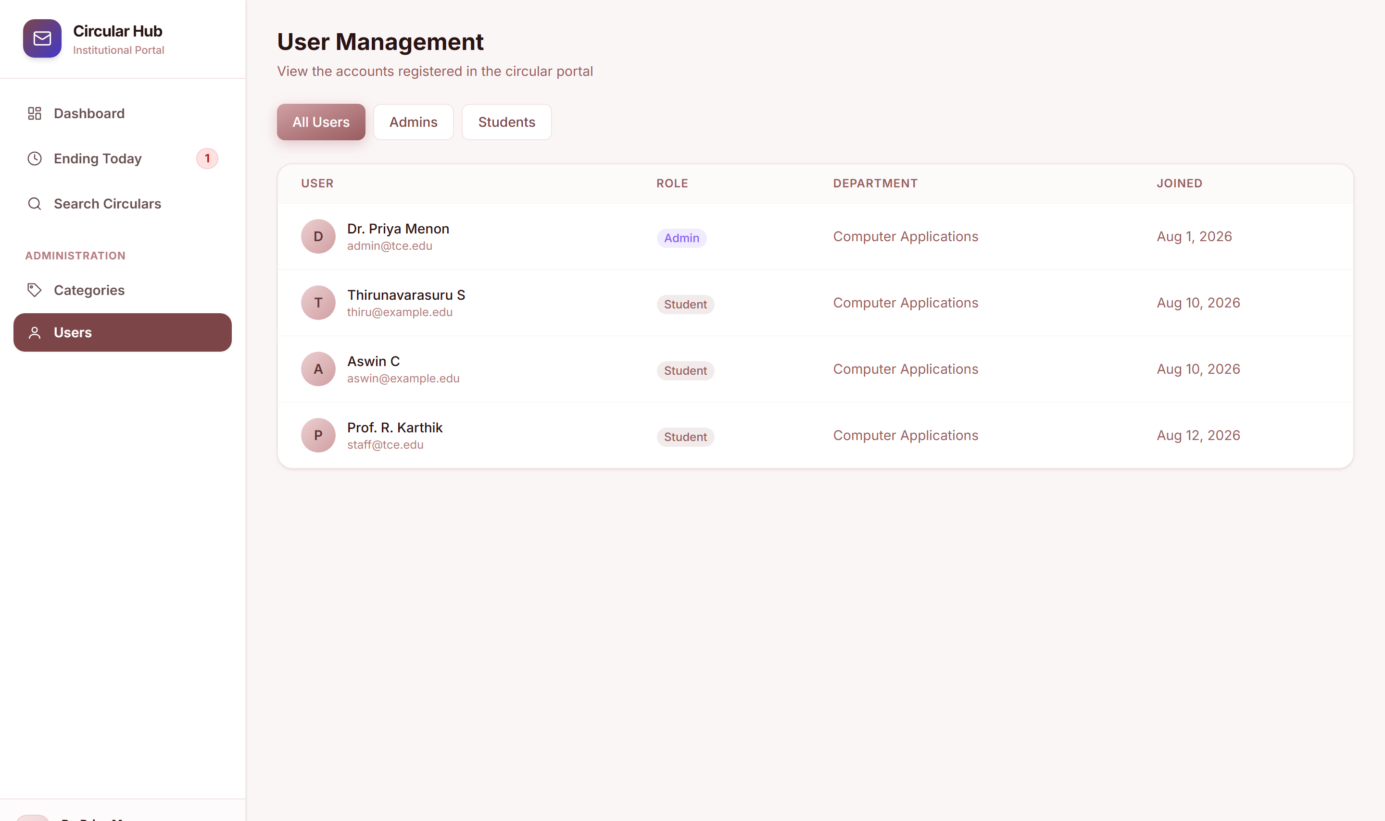
33
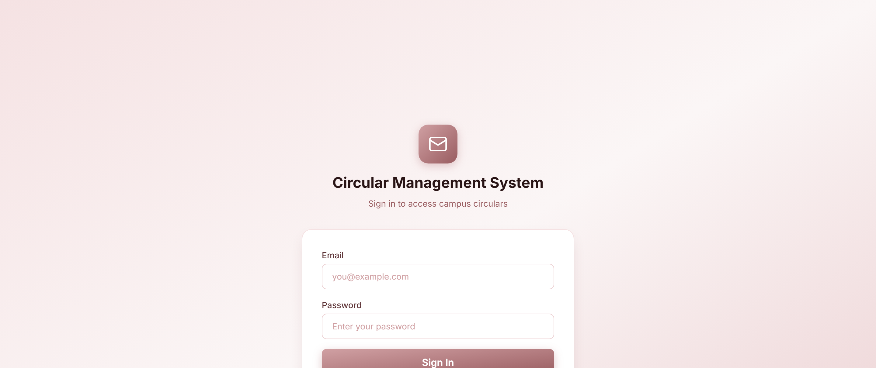
REGISTRATION :

DASHBOARD & DETAIL :
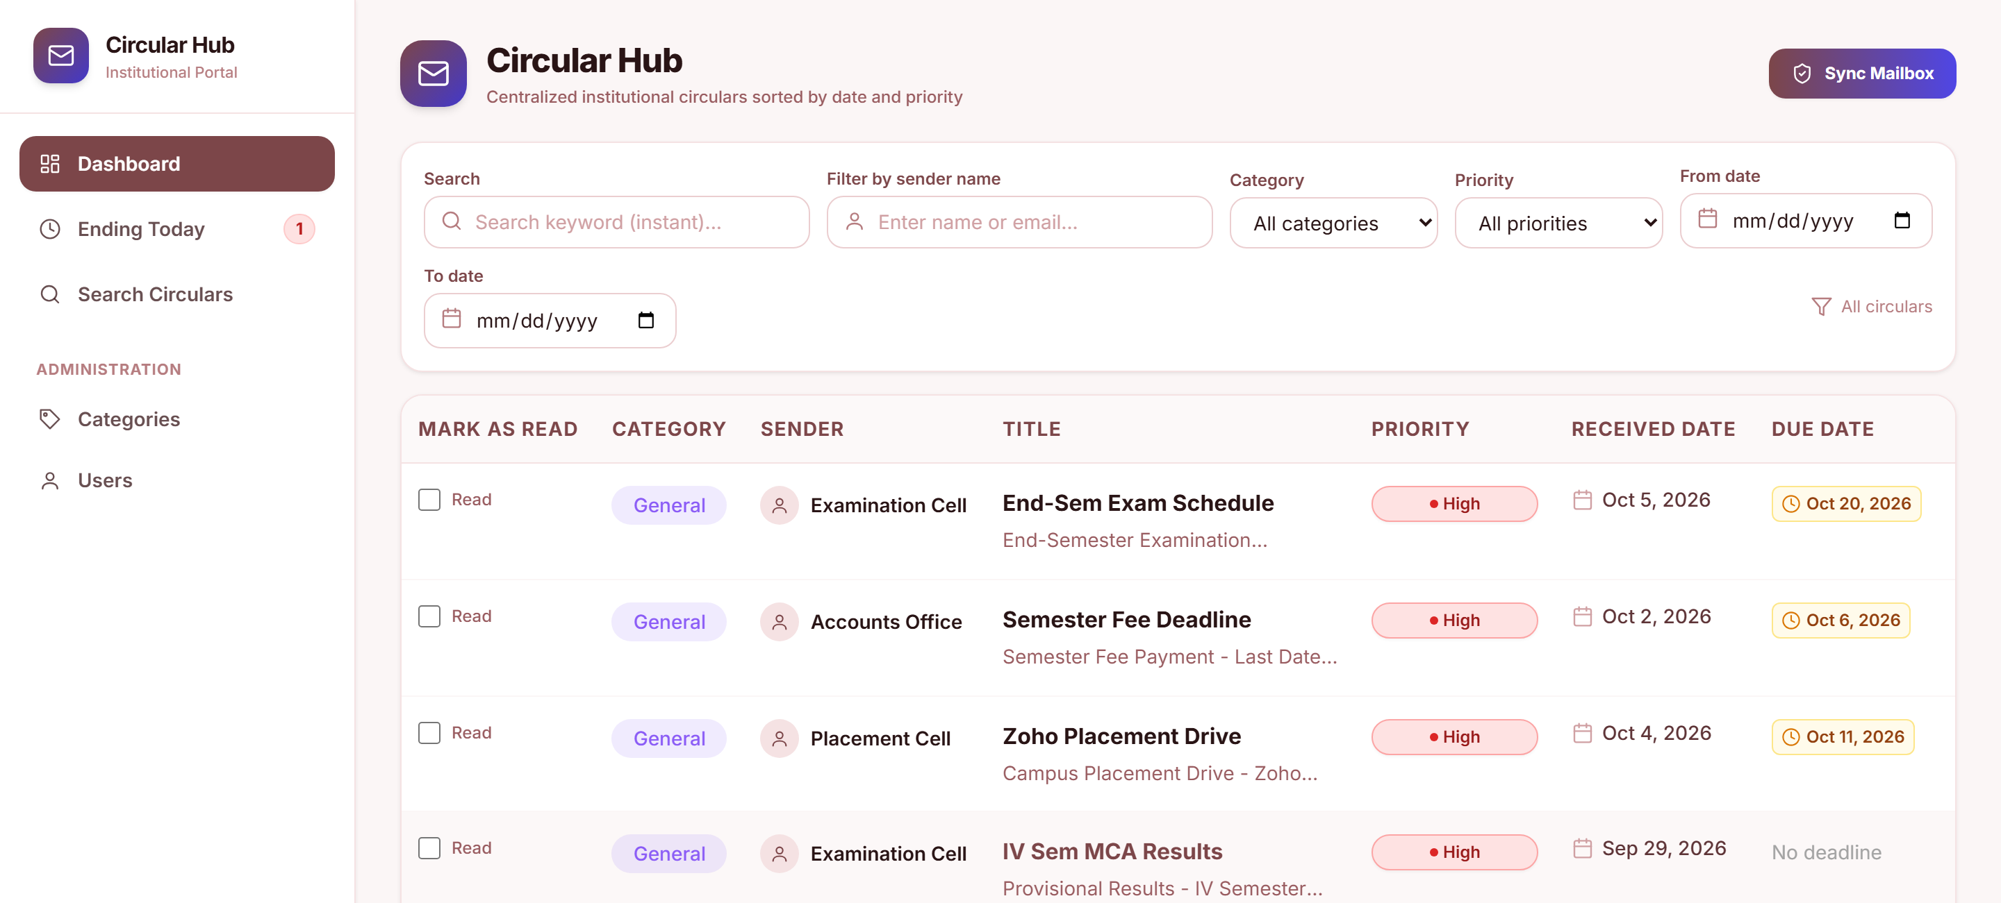
34
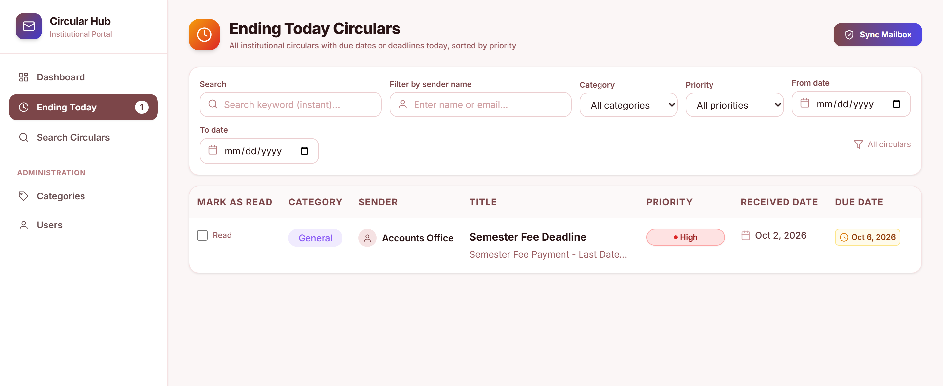
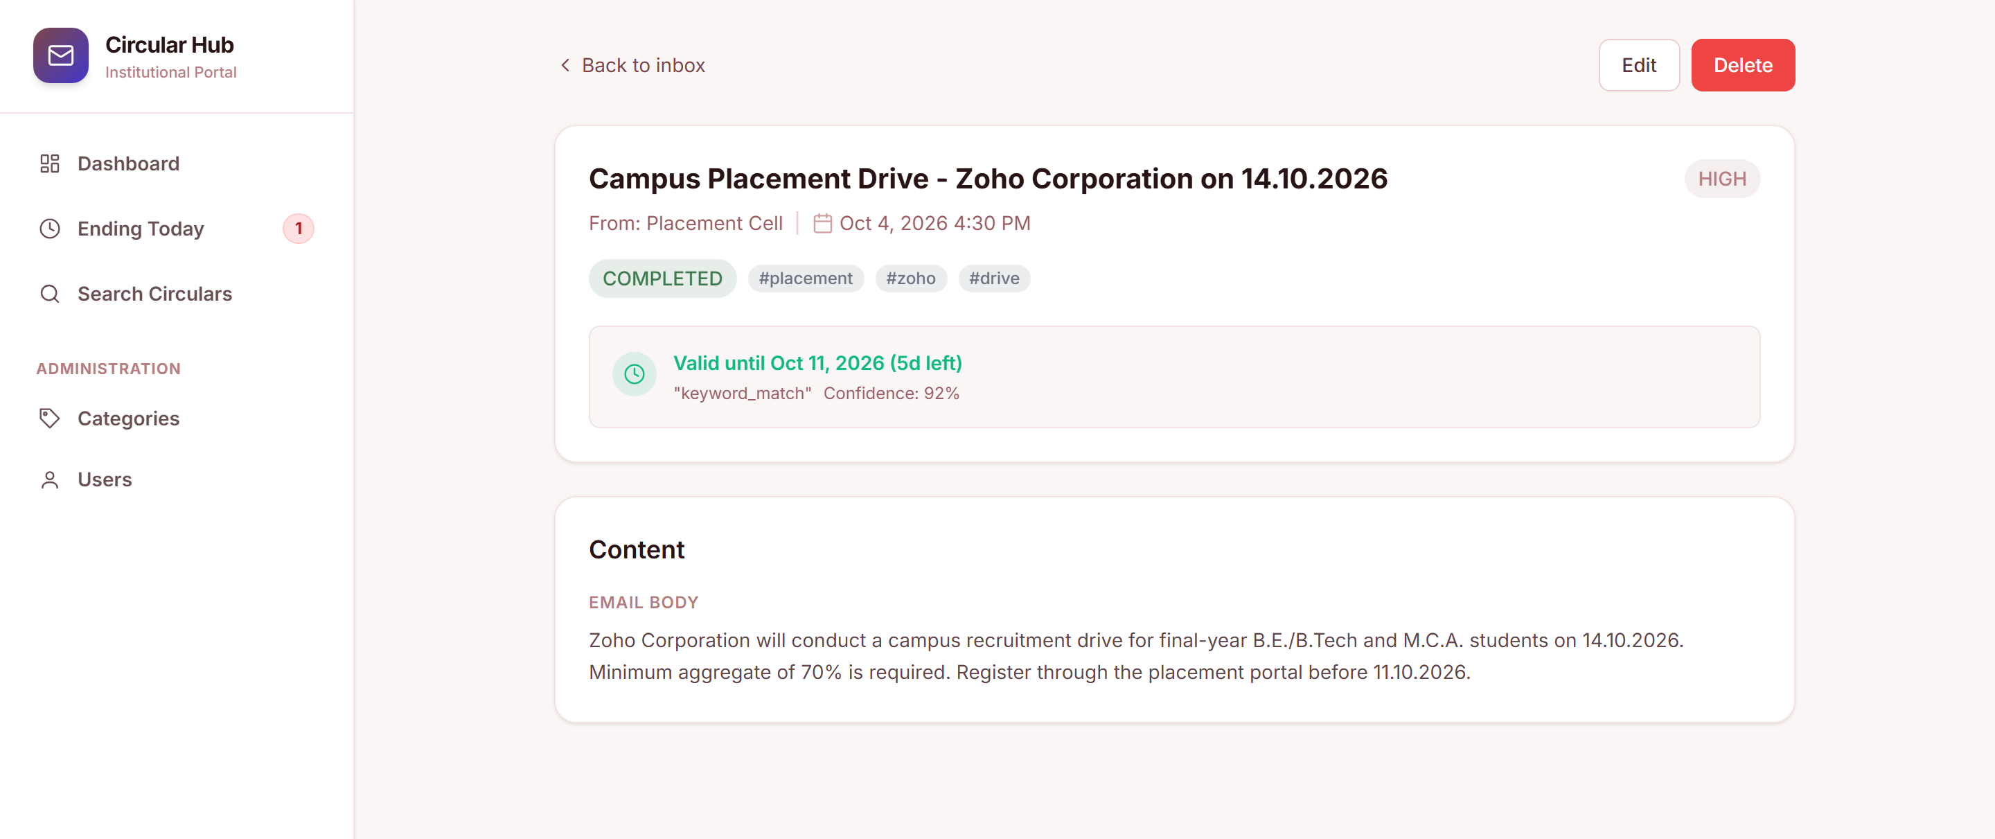
35

